Transmission and Distribution Systems Co-Simulation Tool (TDcoSim)  
  
User Manual

A project funded by  
Office of Electricity  
U.S. Department of Energy

TDcoSim Version 1.1.0  
August 26 2020  
Copyright © 2020, UChicago Argonne, LLC

**Office of Electricity program sponsors:**  
Ali Ghassemian  
Dan Ton  
  
**PI and lead developer:**  
Karthikeyan Balasubramaniam  
  
**Co-developers:**  
Sang-il Yim  
Siby Jose Plathottam  
  
**Project repository:**  
[*https://github.com/tdcosim/TDcoSim*](https://github.com/tdcosim/TDcoSim)

# TDcoSim User Guide

## Table of Contents

1. [Introduction](user_guide_introduction.md)
2. [Getting Started](user_guide_getting_started.md)
3. [Understanding the config file](user_guide_understanding_config.md)
4. [T & D co-simulation details](user_guide_cosimulation_details.md)
5. [Capabilities and Limitations](user_guide_capability_and_limitations.md)
6. [Using TDcoSim in Python scripts](user_guide_using_tdcosim.md)
7. [Software details](user_guide_software_details.md)
8. Examples
   * [Example 1 - Dynamic Studies with single distribution system without disturbances](examples/Example_1_system_state_initialization_test.md)
   * [Example 2 - Dynamic Studies with single distribution system with disturbances](examples/Example_2_test_of_DER_RT_and_trip.md)
   * [Example 3 - Dynamic Studies with two distribution system with disturbances](examples/Example_3_test_of_DER_RT_and_trip.md)
   * [Example 4 - Dynamic Studies with eight distribution system with disturbances](examples/Example_4_test_of_DER_RT_and_trip.md)
9. Appendix
   * [Installation](user_guide_installation.md)
   * [System requirements](user_guide_sys_requirements.md)
   * [References](user_guide_references.md)
   * [Software License](../../LICENSE.md)

# Introduction

Argonne’s transmission and distribution systems co-simulation tool (**TDcoSim**) is a powerful tool to conduct studies that capture short- and long-term interactions between transmission and distribution systems with and without distributed energy resources (DER). It is capable of both steady-state and dynamic simulations. Consideration of inverter-based DER dynamics along with its protection and controls are among the most salient features of this tool. **TDcoSim** is designed to be used in offline planning, operational, and control studies. Transmission system entities can use the tool to study high-penetration DER scenarios, which will assist in ensuring secure, reliable, and economic grid planning and operations.

This manual intends to introduce users to **TDcoSim**, provide a step-by-step guide to its installation and use, and offer examples of its capabilities as a tool for conducting studies. A list of case studies possible with **TDcoSim** can be found here and a brochure with FAQ related to the project goals can found [here](https://www.wecc.org/Administrative/ANL-TD%20co-simulation%20tool%20informational%20brochure.pdf).

## What is TDcoSim?

**TDcoSim** is a software tool that can be used to perform static and dynamic co-simulation of transmission and distribution networks as well as DER. Currently, the tool has incorporated dynamic photovoltaic (PV) systems (referred to as PV-DER) for its dynamic simulation capabilities. Dynamic models of other inverter-based distributed generations (DG) (e.g. battery energy storage systems (BESS), wind turbines (WT)) will be included in future versions. Interested users can also integrate their own dynamic DER models into the tool.

Fig. 1. below illustrates the various components that currently can be simulated using **TDcoSim**. It features a representative IEEE 14-bus transmission system, IEEE 13-bus distribution systems, and solar PV-DERs. Please note that [Solar PV-DER simulation-utility](https://github.com/sibyjackgrove/SolarPV-DER-simulation-utility) is used to simulate PV-DER’s in dynamic T&D co-simulations. Default OpenDSS standard generator models for PV or other DER are used in steady-state T&D co-simulations.

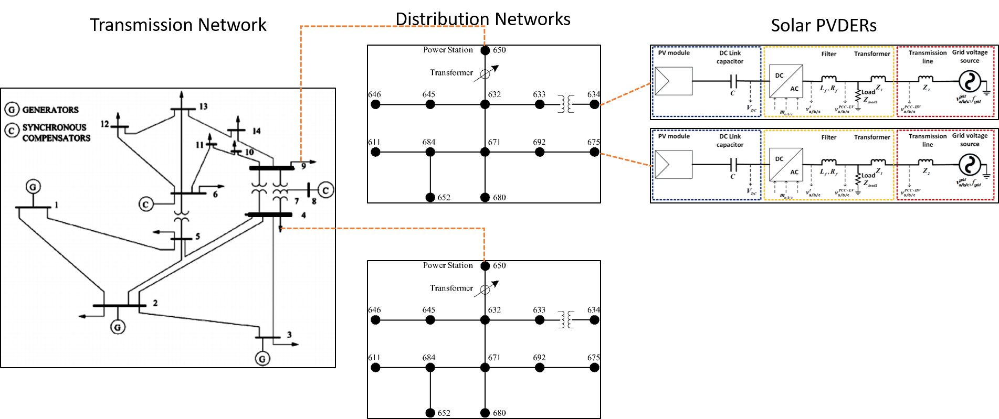

14-bus transmission, 13-bus distribution network, and Solar PVDER

Fig. 1. Components that can be simulated using TDcoSim.

## How can I use it?

**TDcoSim** is available as an open source Python package and can be installed at no cost from its [GitHub repository](https://github.com/tdcosim/TDcoSim) . Additionally, the user needs to separately install [PSS®E](https://new.siemens.com/global/en/products/energy/services/transmission-distribution-smart-grid/consulting-and-planning/pss-software/pss-e.html) for simulating a transmission network, [OpenDSS](https://sourceforge.net/projects/electricdss/) for simulating distribution networks, and [Solar PV-DER simulation-utility](https://github.com/sibyjackgrove/SolarPV-DER-simulation-utility) for simulating dynamic PV-DERs.

Detailed installation instructions and links to the requisite supporting software can be found [here](user_guide_installation.md#installation).

## What are the inputs?

In order to run a co-simulation using **TDcoSim**, the user needs to provide the following inputs:

* A Transmission system model in a format compatible with PSS/E (required)
* Distribution system models in a format compatible with OpenDSS (required)
* Simulation type - steady-state or dynamic (required)
* DER penetration levels (required for dynamic co-simulation)
* DER ratings and ride through settings (optional)
* Simulation events (optional)

Detailed description of each input can be found [here](user_guide_getting_started.md#getting-started-with%20TDcoSim).

## What are the outputs?

**TDcoSim** provides following outputs from each component of the T&D co-simulation:

* Transmission bus: voltage, frequency, load active and reactive power consumption (if a bus is connected with a load), generator active and reactive power output (if a bus is connected with a generator).
* Distribution feeder node: voltage, active and reactive load, DER active and reactive power output (if a bus is connected with a DER).

Please note that the output comes in an interval of half-a-cycle for dynamic simulations. For steady-state simulations, the output comes at an interval corresponding to the time step of users’ choice, which can range from seconds, minutes, hours, to years.

The output format is an Excel spreadsheet.

## Types of studies

**TDcoSim** is intended to be used as a tool for studying static and dynamic impacts of distributed energy resources on the transmission system. Studies that can be conducted with the current version of the software are listed below:

* Steady-state studies
  1. Impact of DER on bulk power system load following or ramping requirements throughout the day and over the course of the seasons.
  2. Analyze voltage profile of both T-system and D-system with varying levels of DER penetrations.
  3. Impact of different DER penetration levels on the voltage stability of BES via continuations power flow analysis.
* Dynamic studies
  1. Impact of DER’s tripping/ride-through settings on bulk power system stability (both frequency and voltage) during and post transmission system faults.
  2. Parameterization and performance verification of DER_A and composite load model.
  3. Impact of DER on the small-signal stability of bulk power system

***Note:*** Examples of dynamic studies performed with TDcoSim are included in the **Examples** section.

## Future development

The studies that can be conducted in the next version of the software are listed below:

* Dynamic studies
  1. Impact of cloud cover events on conventional synchronous generators and operations of bulk power system.
  2. Impact of DER dynamic reactive power support on bulk power system stability (both frequency and voltage) during and post transmission system faults.
  3. Impact of line outages on bulk power system operations and stability under high-DER-penetration scenarios.
  4. Impact of generator and/or load outages on system frequency under high DER penetration.
  5. Impact of sudden load increase/decrease on the stability of bulk power system.
* Protection studies
  1. Analyze impact of high DER penetration on coordination among distribution-system protection devices and DER protection relays, and other protection schemes such as under voltage load shedding (UVLS) and under frequency load shedding (UFLS) schemes.
  2. Determine (a) appropriate DER frequency and voltage ride-through settings; and (b) distribution system protection devices settings. These settings will help ensure bulk system reliability and also satisfy distribution-system safety requirements (e.g. prevention of unintentional islanding).
  3. Short-circuit analysis.
* T&D operations coordination studies
  1. Aggregation of DER is an effective approach to integrate DER as a dispatchable resource into the planning and operation of distribution and transmission systems. DERMS has emerged as an effective tool sitting between the transmission and distribution operators to manage the aggregation of DERs at the substation and feeder level.
  2. TDcoSim, in conjunction with DERMS, can be used to manage DERs to provide T&D coordinated congestion management, system balancing, frequency and voltage control, and flexibility.

The following figure illustrates how **TDcoSim** can assist in T&D planning and operations coordination for future high-DER-penetration grid.

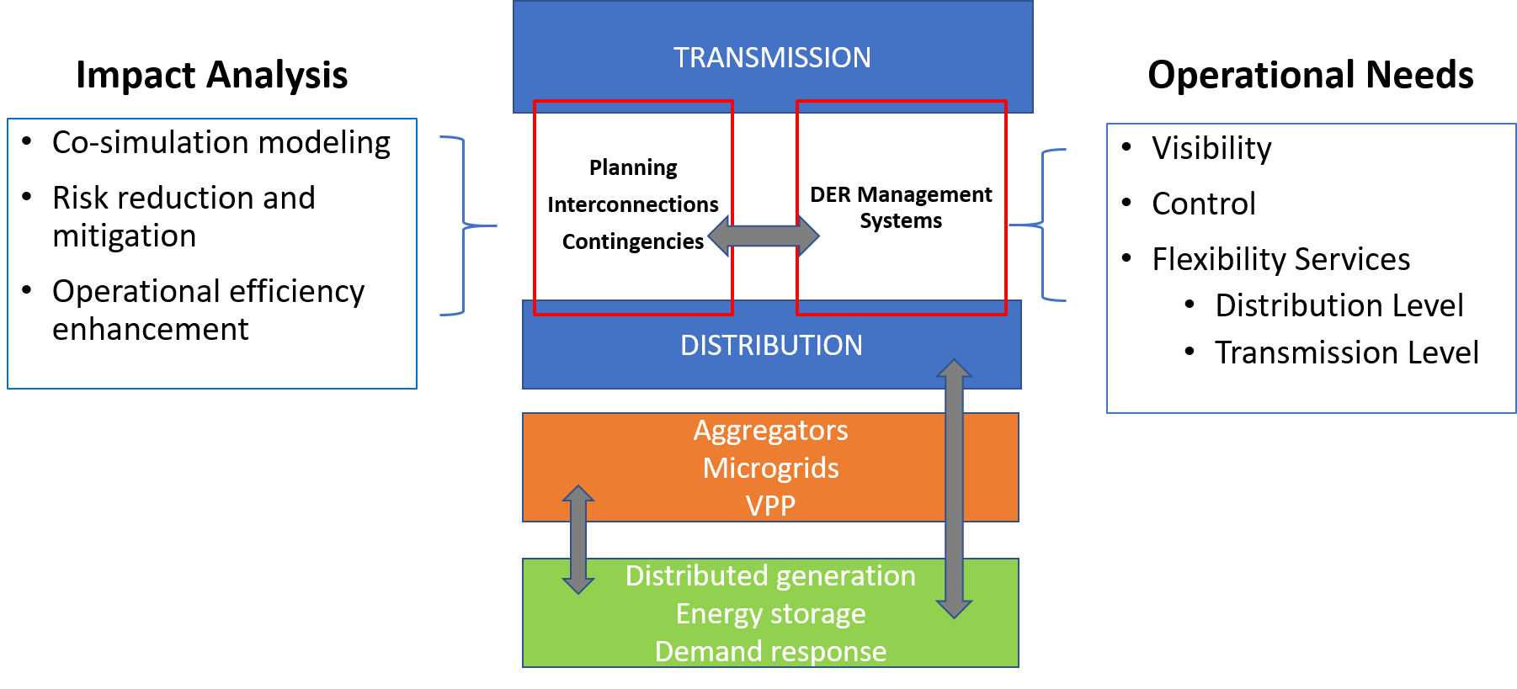

T & D planning and operationsl

Following capabilities are planned in be added in the future:

* Capability to include other types of DERs such as energy battery storage system.
* Capability to introduce insolation change events.
* Capability to simulate generator tripping, line outages, load increase/decrease.
* Capability to consider distribution system UFLS and UVLS schemes.

## Scalability and solution time

The scale of the T & D system (including PV-DERs) to be co-simulated is limited only by the available memory (RAM) in the workstation where **TDcoSim** is installed. The solution time for the dynamic co-simulation depends on the number of distribution feeder instances and DER instances as well as on the number of logical cores available in the workstation.

[Continue to Getting Started](user_guide_getting_started.md) # Getting started with TDcoSim

In this section, we describe how you can get started with using **TDcoSim** to conduct static or dynamic co-simulation studies for T & D systems with different DER penetration levels and various events.

## 1. Setup TDcoSim

Please install the software per installation instructions as the first step (Installation instructions for can be found [here](user_guide_installation.md#installation)). Make sure the system requirements are satisfied (System requirements can be found [here](user_guide_sys_requirements.md)).

## 2. Configure T & D & DER models and simulation scenarios

### Specify parameters

1. Specify parameters for the power system to be analyzed:
   * Transmission system
     + Transmission system model (e.g. IEEE 118 bus system)
     + Buses where distribution system models are attached
   * Distribution system
     + Distribution system model (e.g. IEEE 123 node feeder)
     + Solar PV penetration level as a fraction of the distribution system load
   * DER characteristics (optional)
     + DER voltage and power ratings (e.g. 50 kW, 175 V)
     + DER configuration ID (e.g. ‘50’)
     + DER low voltage ride through settings (e.g. 0.7 p.u., 10 s)
2. Specify whether simulation is static or dynamic.
3. Specify length of simulation (e.g. 5 s).
4. Specify transmission bus fault events (optional).
   * Start and end time of fault (for e.g. 0.5 s, 0.667 s)
   * Bus at which fault occurs and fault impedance value.

***Note:*** Frequency ride through will be included in future version.

***Note:*** Other disturbance events like loss of generator, line trip etc. will be included in future version.

### Transfer the configuration to TDcoSim

The power system models and simulation scenarios defined in the previous section can be transferred to TDcoSim using the **config** file (detailed explanations for every entry in the **config** file is provided [here](user_guide_understanding_config.md#understanding-the-config-file)). The file formats currently supported are:

* Transmission system model: *.raw,* .dyr
* Distribution system model: *.dss

***Note:*** The **config** file can be edited with Notepad++.

***Note:*** The **config** file should be in the same folder as **tdcosimapp.py**.

## 3. Start a co-simulation

Once the **config** file has been filled with the required entries and saved, the user can start the co-simulation by running **tdcosimapp.py** Python script. To do this open the command line prompt within the folder containing the **tdcosimapp.py** and run the following script.

python tdcosimapp.py > log_file.txt

***Note:*** tdcosimapp.py is the default name of script that starts the co-simulation. If desired the user can write his/her own script by following the instructions given [here](user_guide_using_tdcosim.md#tdcosim-advanced-usage).

***Note:*** Logs generated during co-simulation are written to log_file.txt (or any other user specified **.txt file**).

## 4. Accessing the results

Outputs (from both transmission and distribution systems) are saved as an MS Excel file (**.xlsx**) at the end of the co-simulation as shown in Fig. 1. Additionally a PSS/E channel output file (**.out**) is created containing all the simulated quantities from PSS/E.

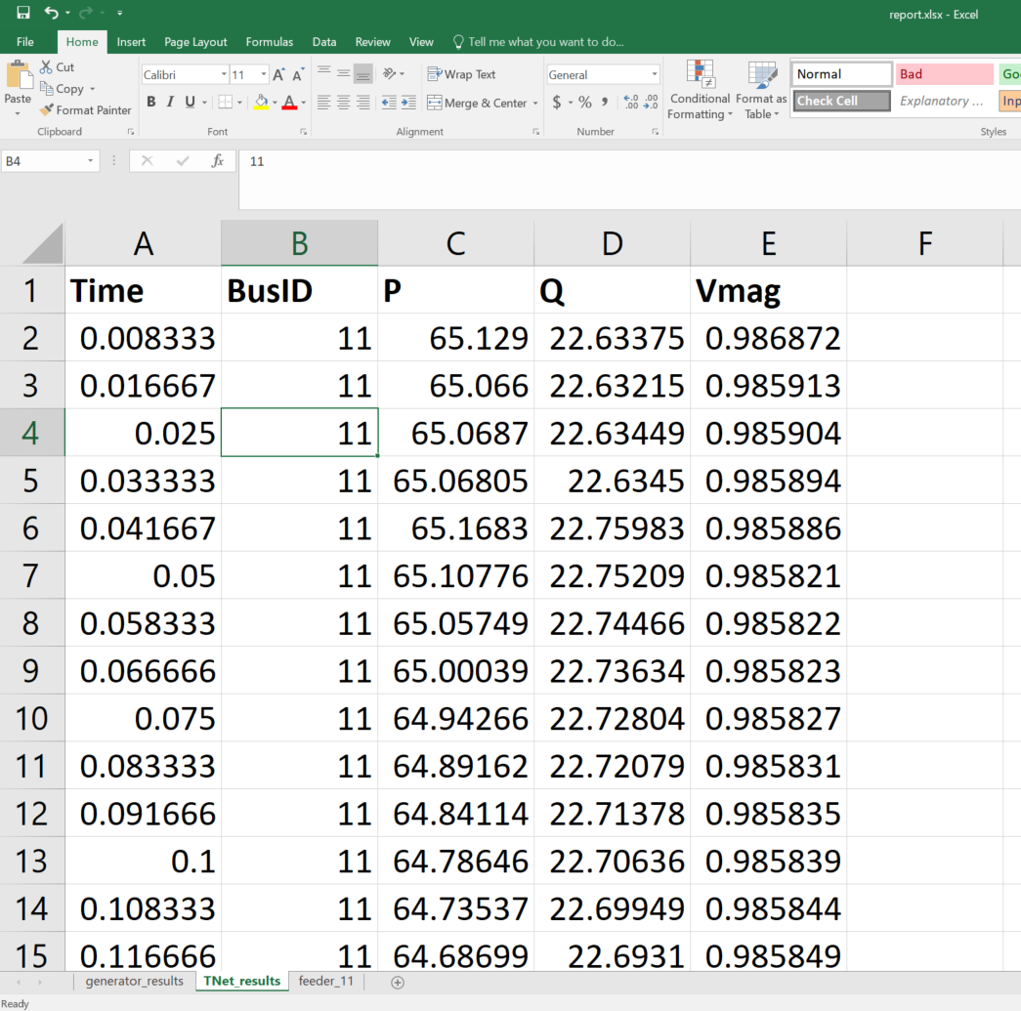

Fig. 1. Dynamic T&D co-simuation report in MS Excel format.

***Note:*** Both the **.xlsx** file and the **.out** file will be found in the same folder as tdcosimapp.py.

## Prebuilt templates

**config** files for static and dynamic co-simulation scenarios are provided in the ‘**examples**’ folder within the TDcoSim repository. These may be run by executing run_qsts.py and run_time_domain.py respectively as shown in step 3 (after replacing tdcosimapp.py with the appropriate file name).

# Understanding the config file

The **config** file is the primary user interface for the TDcoSim package. Before starting the operation of TDcoSim tool and running test cases, it is necessary to understand how the configuration file can be used to setup the simulation conditions. This chapter describes the options within the configuration file and aids the user in setting up a simulation.

## Config file options

The config file can be divided into three sections. The purpose of each option in every section is explained below:

### PSSE configuration

1. **cosimHome (string):** directory containing config file, and models for T and D systems (e.g. "C:\_folder).
2. **psseConfig (dict):** configuration for the transmission system.
   * ***installLocation (string)*** : full path for PSS/E transmission system python library location. If there isn’t a specific location, system will look up the default installation path of PSS/E 33 (e.g. “C:\Program Files\PTI\PSSE35\35.0\PSSPY27”)
   * ***rawFilePath (string)*** : full path for the PSS/E transmission system loadflow case file (e.g. "C:\_folder\\\\118bus\\**case118.raw**").
   * ***dyrFilePath (string)***: full path for the PSS/E transmission system dynamic case file (e.g. "C:\_folder\\\\118bus\**case118.dyr**").

### OpenDSS + DER configuration

The default feeder configuration is **defaultFeederConfig**, which automatically assigns the same feeder to all the transmission system buses unless otherwise configured using **manualFeederConfig**.

1. **openDSSConfig (dict):** Configuration for distribution feeders. The user can choose a default feeder configuration through defaultFeederConfig option or specify individual feeder for each transmission bus through manualFeederConfig option.
   * ***defaultFeederConfig (dict):*** Default feeder configuration that assigns identical distribution feeders to all the transmission buses.
     + *filePath (string):* Specifies the path for the OpenDSS File (e.g. "C:\_folder\\\\123bus\\**case123ZIP.dss**").
     + solarFlag (Boolean): Specifies presence or absence of PV-DERs in a feeder.
     + *solarPenetration (float):* Specifies the total rated capacity of PV-DERs as a percentage of the total feeder load in dynamic co-simulation (e.g. 0.1).
   * ***manualFeederConfig:*** Manually specify the distribution system configuration at the desired transmission bus.
     + *nodes (list of dict):* Specifies the configuration of the distribution system and DERs.
       - *nodenumber (integer)*: Specifies the transmission bus to which the distribution system will be connected.
       - *filePath (string)*: Specifies the path for the OpenDSS File containing the distribution system model. (e.g. "C:\_folder\\\\123bus\\case123ZIP.dss")
       - *solarFlag (bool):* Specifies presence or absence of PV-DERs in the distribution system.
       - *DERFilePath (string)*: Specifies the path for the JSON file containing the parameters and settings defining the DER model. Note that a single file may contain settings for any number of DER models.
       - *initializeWithActual (bool)*: If ***true***, the actual power output from the DER model instance will be used when setting up T+D co-simulation. If ***false***, the rated power output given in DER settings will be used.
       - *DERSetting (string)*: Specifies DER configuration at each node. If ***PVPlacement***, the DER at each node will use a unique set of DER settings. If ***default***, DERs at all nodes will use the same DER settings.
       - *DERModelType (string)*: The type of DER model to be used in each node of the particular feeder. Valid options are: “ThreePhaseUnbalanced”,“ThreePhaseBalanced”,“ThreePhaseUnbalancedConstantVdc”.
       - *DERParameters* (dict): Specifies the configuration of PV-DERs to be used in the distribution system. If *PVPlacement* **is provided**, the DER at each node will need a separate set of DER settings. If *default* **is provided**, DERs at all nodes will use the same DER settings.
         * *default*: DER settings that will be used if *DERSetting* is *default*. Note that these settings are optional if *DERSetting* is *PVPlacement*.

*solarPenetration (float)*: Specifies the total rated capacity of PV-DERs as a percentage of the total feeder load in dynamic co-simulation (e.g. 0.1). It will only be used if *DERSetting* is *default*.

*derId (string)*: The key word corresponding to DER model that is available in DER config file. Note that an exception will be thrown if a matching *derId* is not found in the DER config file.

*powerRating (float)*: Specifies the rated power of DER in kVA. Note that value specified here will override the rated power given in the DER config file.

*VrmsRating (float):* Specifies the rated RMS voltage (L-G) of the DER in Volts. The tool automatically adds a transformer to connect the DER to the distribution system. Note that value specified here will override the rated voltage given in the DER config file.

*steadyStateInitialization (bool):* Specifies whether the states in PV-DER model is to be initialized with steady state values before simulation is started.

*pvderScale (float):* Specifies the scaling factor with which to multiply the DER power output from any given node. A higher value of *pvderScale* for similar *solarPenetration* will result in lower number of DER model instances.

*LVRT (dict):* Low voltage ride through settings. Either a pre-defined configuration available in *config_der.json* may be provided or an arbitrary number of ride through settings may be defined based on voltage thresholds.

*config_id (string):* Specifies the LVRT configuration available in the *config_der.json* that should be used.

*V_threshold (float):* Specifies the voltage threshold for low voltage anomaly in p.u.

*t_threshold (float):* Specifies the trip time threshold for low voltage anomaly in seconds.

*mode (string):* Specifies the DER operating behavior during ride through (options: ‘momentary_cessation’,‘mandatory_operation’).

*HVRT (dict):* High voltage ride through settings. An arbitrary number of ride through settings may be defined based on voltage thresholds.

*V_threshold (float):* Specifies the voltage threshold for high voltage anomaly in p.u.

*t_threshold (float):* Specifies the trip time threshold for high voltage anomaly in seconds.

*mode (string):* Specifies the DER operating behavior during ride through (options: ‘momentary_cessation’,‘mandatory_operation’).

*VRT_delays (dict):* Time delay settings for power output cessation and output restoration.

*output_cessation_delay (float):* Specifies the time delay before power output from DER ceases.

*output_restore_delay (float):* Specifies the time delay before DER starts restoring power output after momentary cessation.

* + - * + *PVPlacement (dict):* Specifies the distribution system node and the details of the DER to be connected to that node. Note that these settings are optional if *DERSetting* is *default*.

*node (string)*: Any three phase node in the OpenDSS model. Note that the keyword ***node*** must be replaced with the actual node name.

*derId (string)*: The key word corresponding to DER model that is available in DER config file. Note that an exception will be thrown if a matching *derId* is not found in the DER config file.

*powerRating (float)*: Specifies the rated power of DER in kVA. Note that value specified here will override the rated power given in the DER config file.

*pvderScale (float):* Specifies the scaling factor with which to multiply the DER power output from any given node.

*VrmsRating (float):* Specifies the rated RMS voltage (L-G) of the DER in Volts. The tool automatically adds a transformer to connect the DER to the distribution system. Note that value specified here will override the rated voltage given in the DER config file.

***Note:*** Please check sections 6.4.1 and 6.4.2 in [IEEE 1547-2018](https://standards.ieee.org/standard/1547-2018.html) for more information on voltage ride-through and trip settings.

### Simulation configuration

1. **simulationConfig (dict):** Configuration options for the simulation.
   * ***simType (string):*** A string specifying whether the simulation is **‘static’** or **‘dynamic’**.
   * ***dynamicConfig (dict):*** Configuration options for **‘dynamic’** simulation.
     + *events (dict):* Specifies the various events in the dynamic simulation listed sequentially.
       - *time (float):* Specifies the time at which an event occurs.
       - *type (string):* Specifies the type of an event (**‘simEnd’**, **‘faultOn’** or **‘faultOff’** ).
       - *faultBus (integer):* Specifies the transmission bus at which the fault occurs.
       - faultImpedance (list of floats): Specifies the impedance of the fault.
   * ***staticConfig (dict):*** Configuration options for **‘static’** simulation.
     + *loadShape (list of floats):* Load served by the T+D system at each time interval (e.g. [0.81,0.75,0.72,..])
   * ***protocol (string):*** Specifies the nature of coupling between Transmission system and Distribution System (valid options:**‘loose_coupling’**,**‘tight_coupling’**).

***Note:*** Tight coupling protocol is only available for static co-simulation in current version.

***Note:*** For static co-simulation, solar penetration needs to be implemented through the **.dss** file. Option to add solar shape through config file will be implemented in next version.

### Output configuration

1. **outputConfig (dict):** Configuration options for the data generated during simulation..
   * ***outputfilename (string):*** File name under which the data generated during simulation would be stored.
   * ***type (string):*** Format in which the data generated during simulation would be stored.

## config.json example

The example below shows the **config** file for a T & D **dynamic** co-simulation with a [IEEE 118 bus transmission system](https://icseg.iti.illinois.edu/ieee-118-bus-system/) having [IEEE 123 node test feeder](http://sites.ieee.org/pes-testfeeders/resources/) connected to all the buses for a simulation lasting for **1.0** seconds, with **0 %** PV-DER penetration.

{  
 "cosimHome":"C:\\Users\\username\\Documents\\TDcoSim\\CoSimulator",  
 "psseConfig":{  
 "rawFilePath":"C:\\Users\\username\\Documents\\TDcoSim\\SampleData\\TNetworks\\118bus\\case118.raw",  
 "dyrFilePath":"C:\\Users\\username\\Documents\\TDcoSim\\SampleData\\TNetworks\\118bus\\case118.dyr"   
 },  
 "openDSSConfig":{   
 "defaultFeederConfig":{  
 "filePath":["CC:\\Users\\username\\Documents\\TDcoSim\\SampleData\\DNetworks\\123Bus\\case123ZIP.dss"],  
 "solarFlag":0,  
 "solarPenetration":0.0  
 },  
 },  
 "simulationConfig":{  
 "simType":"dynamic",  
 "dynamicConfig":{  
 "events":{  
 "1":{  
 "type":"simEnd",  
 "time":1.0  
 }  
 }  
 },  
 "protocol":"loose_coupling"  
 }  
}

# T&D co-simulation with PSS/E and OpenDSS

This section provides a brief overview of T & D co-simulation with PSSE and OpenDSS as implemented in TDcoSim.

## Advantages

The state-of-the-art approach of studying DER impact on the bulk power system entails developing aggregate positive-sequence load and DER model for distribution systems and then applying these models in conventional positive-sequence transmission system simulation software such as PSSE, PSLF, etc.

**TDcoSim** offers higher degree of fidelity since there is no need to parameterize the aggregate load and DER models for distribution system, which are only approximate representation of actual distribution system behaviors,

**TDcoSim** also offers time savings by running an integrated T&D co-simulation compared to the approaches of running separate simulations for T&D systems and manually combining the results.

## Assumptions in current software version

1. It is assumed that all the distribution feeders connected to the transmission system load bus have the same characteristics. Hence only one distribution feeder is simulated in an OpenDSS instance. The power output from the single feeder is then multiplied with a scaling factor (calculated automatically by TDcoSim) so that we can match the rated load at the transmission bus with the total load from all the feeders connected to the bus.
2. No Sub-station is explicity added to the distribution network model by TDcoSim to interface the T bus with the distribution feeder. However if the user provided distribution network model comes with a sub-station, then it is used.

## T&D interface

The transmission system simulator (TSS) and distribution system simulator (DSS) are separate programs with their own solution methods. **TDcoSim** is responsible for exchanging data and synchronizing their runs.

### Data exchange

The TSS, PSSE uses positive sequence quantities while the DSS, OpenDSS uses phase quantities. Hence it is necessary to convert positive sequence quantities to equivalent phase quantities and vice-versa. After PSSE completes a solution, it outputs the sequence voltages at the T&D interface. Then (1) is applied to convert the sequence voltages at the boundary bus to phase voltages. Using the phase voltages at the boundary bus, the DSS completes a solution and outputs the phase current injection at the boundary bus, which are expressed in (2).

$$ \begin{equation} \left[\begin{array} {r} \bar{V}_{DS,a}\\\bar{V}_{DS,b}\\\bar{V}_{DS,c} \end{array}\right]= \left[\begin{array} {r} 1\\1\angle-120\\1\angle120 \end{array}\right].\bar{V}_{TS,+}\tag{1} \end{equation} $$

$$ \begin{equation} I_{DS}= \left[\begin{array} {r} \bar{I}_{DS,a}\\\bar{I}_{DS,b}\\\bar{I}_{DS,c} \end{array}\right]\tag{2} \end{equation} $$

The phase current injection at the boundary bus is converted to sequence quantities using (3). The current injection at the boundary bus is then used to obtain complex power injection at the boundary bus using (4).

$$ \begin{equation} \left[\begin{array} {r} \bar{I}_{DS,0}\\\bar{I}_{DS,+}\\\bar{I}_{DS,-} \end{array}\right]= \frac{1}{3}\left[\begin{array} {rrr} 1&&1&&1\\1&&a&&a^2\\1&&a^2&&a \end{array}\right]\left[\begin{array} {r} \bar{I}_{DS,a}\\\bar{I}_{DS,b}\\\bar{I}_{DS,c} \end{array}\right]\tag{3} \end{equation} $$

$$ \begin{equation} S_{TS,+}=3.\bar{V}_{TS,+}.\bar{I}^*_{TS,+}\tag{4} \end{equation} $$

The obtained value of S_TS,+ is used as the total power requirement for the said load bus at the transmission system. It is worth mentioning that the equivalent load that is replaced with the distribution system simulator is modeled as a constant power load with respect to the transmission system simulator. The data exchange across the T&D interface is illustrated in Fig. 1 where the loosely-coupled synchronization protocol is utilized (The synchronization protocols will be introduced in the next section).

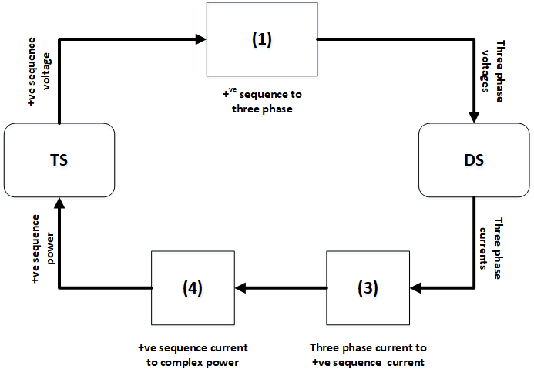

loosely coupled protocol

Fig. 1. Loosely couple protocol for data exchange across T&D interface.

### Synchronization

Both static and dynamic co-simulations starts with an initialization for both PSSE and OpenDSS software. The T&D interface contains sockets that enable simulators to communicate and exchange data. Specifically, the TSS and the DSS are synchronized through two protocols, namely, loosely-coupled and tightly-coupled protocols.

#### Loosely-coupled protocol

The loosely-coupled protocol is illustrated in Fig. 2. There is a one-step lag in information exchange between transmission and distribution, but less computation is required.

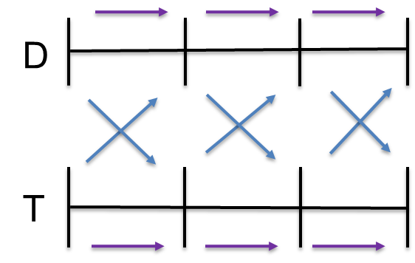

Fig. 2. Loosely-couple protocol.

## Steady-state T&D co-simulation process

The data exchange protocol for steady-state co-simulation in the current version of the software may be tightly-coupled or loosely-coupled. The initialization steps are:

1. Input case files (both PSSE and OpenDSS).
2. Run power flow in PSSE.
3. Get voltage (p.u.) at load buses from PSSE.
4. Set OpenDSS VSource voltage to be equal to the voltage from the respective load bus.
5. Run power flow in OpenDSS, get P and Q requirement for DNetworks.
6. Scale P & Q using scaling factor and set as input to T bus.

The scaling factor (see assumptions) is calculated by dividing the total load at a transmission system load bus by the aggregated load of one distribution feeder.

At every time step (one half-cycle), the steps 2 to 6 are repeated untill the end of simulation.

## Dynamic T&D co-simulation process

The data exchange protocol for dynamic co-simulation in the current version of the software is loosely coupled. The initialization steps are:

1. Input case files (both PSSE and OpenDSS).
2. Run power flow in PSSE.
3. Get voltage (p.u.) at load buses from PSSE.
4. Set OpenDSS VSource voltage to be equal to the voltage from the respective load bus.
5. Run power flow in OpenDSS, get P and Q requirement for DNetworks.
6. Compute difference of P & Q between TNetworkBus and DNetwork.
7. Calculate compensating shunt value using $P_{shunt}+j*Q_{shunt}=V_{pu}^{2}*(YP_{shunt}-YQ_{shunt})$.
8. Add $YP_{shunt}$ and $YQ_{shunt}$ as fixed compensating shunt in PSSE.

At every time step (one half-cycle), the steps 2 to 8 are repeated until the user specified simulation end time is reached.

# Capability and Limitations

**TDcoSim** uses PSS®E as transmission system simulator and OpenDSS as Distribution system simulator. In general, **TDcoSim** can be used for analysis that is supported by PSS®E and OpenDSS. On the other end of the spectrum **TDcoSim** is limited by the limitations of PSS®E and OpenDSS. PSS®E is a positive sequence simulator, as a result, studies that involve unbalanced faults on the transmission side cannot be studied in detail.

## Types of Analysis

* Quasi-static time series (QSTS)
  + Solves power flow for both transmission and distribution system
  + Uses a tightly-coupled scheme to interface T&D systems
  + Use of tightly-coupled scheme ensures that the obtained boundary solutions are stable. In other words the solution will be the same (within a user defined tolerance) if one were to solve both the T&D system together as a single large system.
  + Loadshapes can be provided in the configuration file to model the change in load over time. It is assumed that all the loads in a given distribution feeder follow the same loadshape.
* Dynamic simulation
  + Unlike the QSTS, which solves a set of algebraic equations on both the T and the D side, the dynamic simulation solves differential algebraic equations (DAEs) on the T-side and D-side
  + OpenDSS solves power flow for the distribution system
  + When distributed solar generation is modeled, the dynamic model of [PVDER](https://github.com/sibyjackgrove/SolarPV-DER-simulation-utility) is used. Thus, the combination of OpenDSS and PVDER makes the D-side equations DAEs.
  + Depending on the configuration multiple pvder instances will be used
  + Balanced faults on the transmission side can be modeled
  + Cloud cover event – particularly relevant for system studies involving large solar farms
  + Uses a loosely-coupled

## Assumptions on Reduction in System Inertia

**TDcoSim** was specifically designed to study distributed energy resource (DER) integration. Hence, it is designed to support two different viewpoints, * The user can defined the system in detail using existing study models, or * The user can setup future scenarios with varying levels of solar penetration

**TDcoSim** makes certain assumptions in the latter case. As an example, let us say the user wants to study 10 and 20 percent solar penetration scenarios. In both the cases, the user will provide the same T and D systems. This means certain amount of conventional generation from the transmission system needs to be reduced in order to accomodate the increased solar generation. The realistic way to accomplish this would be to find out the units committed for the given scenario, run an optimal power flow to find the generator set points, then start the simulation at that operating point. However, the data required to do that is not typically available and/or not provided by the user. **TDcoSim** overcomes this problem by making the following assumptions,

* Reduce generation of each unit by solar penetration value. For example, if solar penetration is 10 percent then reduce each generator output by 10 percent.
* Reduce the inertia constant of each generator the same way

# TDcoSim advanced usage

## Importing TDcoSim

TDcoSim can be imported and used like a normal Python module. Note that package name is in lower case.

import tdcosim

## Using TDcoSim within your script

The basic steps to write your own co-simulation program are as follows:

1. Setup desired T+D or T+D+DER system by making necessary entries in the [**config**](user_guide_understanding_config.md) file.
2. Import necessary classes.

* from tdcosim.report import generateReport  
   from tdcosim.global_data import GlobalData  
   from tdcosim.procedure.procedure import Procedure

1. Read the **config** file and initialize the T&D system.

* GlobalData.set_config('config.json')  
   GlobalData.set_TDdata()

1. Create a procedure object for the simulation and call *simuate()* method.

* procedure = Procedure()  
   procedure.simulate()

1. Generate report after *simuate()* exits.

* generateReport(tdcosim.GlobalData,fname='report.xlsx')

[Continue to Software details](user_guide_software_details.md)

# Software details

## Features

The software has the following features.

1. Capable of launching sub-processes for individual feeders. The parallelization helps improves the scalability of the software.
2. Capable of configuring each feeder with different DER penetration levels, ratings, and voltage ride through settings (compatible with IEEE Std 1547-2018).
3. Capable of introducing fault events during simulation.
4. Captures and reports data from both transmission and distribution system for the entirety of the co-simulation.

## Main components

**TDcoSim** comprise interface modules and a synchronization module. There are separate interface modules with sockets and interaction protocols for both the T & D and D & DER co-simulations.

**1. T&D interface:** A Python program that exchanges and iterates information (voltages, currents, and powers) between T&D simulators through synchronization protocols (loosely or tightly-coupled). The Python-based T&D interface is easy to use and adds minimal overhead.

**2. D&DER interface:** A Python program that exchanges information between the distribution system simulator and the dynamic DER model.

**3. Configuration file:** It is the main user interface where the user can configure a T+D or T+D+DER co-simulation.

## External components

1.[PSS®E](https://new.siemens.com/global/en/products/energy/services/transmission-distribution-smart-grid/consulting-and-planning/pss-software/pss-e.html) It is an off-the-shelf positive-sequence transmission system simulator.

2.[OpenDSS](https://www.epri.com/#/pages/sa/opendss) It is a three-phase unbalanced distribution system simulator.

3.[Solar PV-DER simulation utility](https://github.com/sibyjackgrove/SolarPV-DER-simulation-utility) It is Python utility than can simulate dynamics of grid connected solar PV-DER systems. It uses dynamic phasor models and has single and three-phase PV-DERs.

## Software architecture

A schematic showing the software architecture of the TDcoSim package is shown in the Fig. 1.

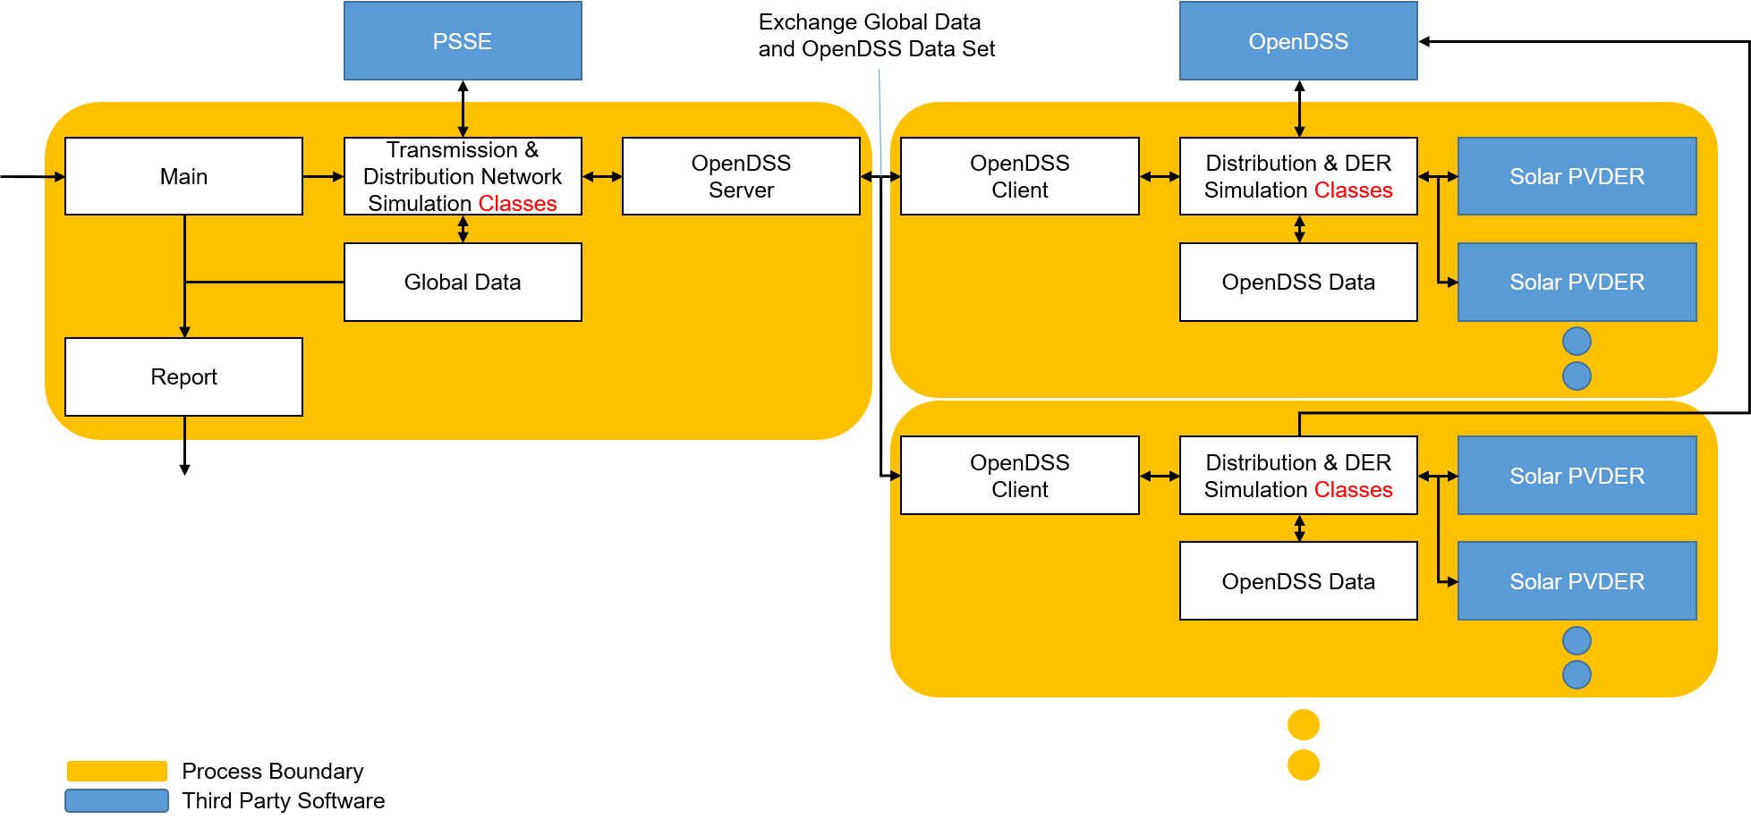

Fig. 1. Highlevel software architecture

TDcoSim runs with multiple processes. The main process runs the transmission network simulation with PSSE and generates a report of the simulation. Each sub-processes runs the distribution network simulation with OpenDSS and PV-DER. The tool uses the TCP sockets to exchange the data between main and sub-processes. The detailed simulation architecture is shown in the Fig.2.

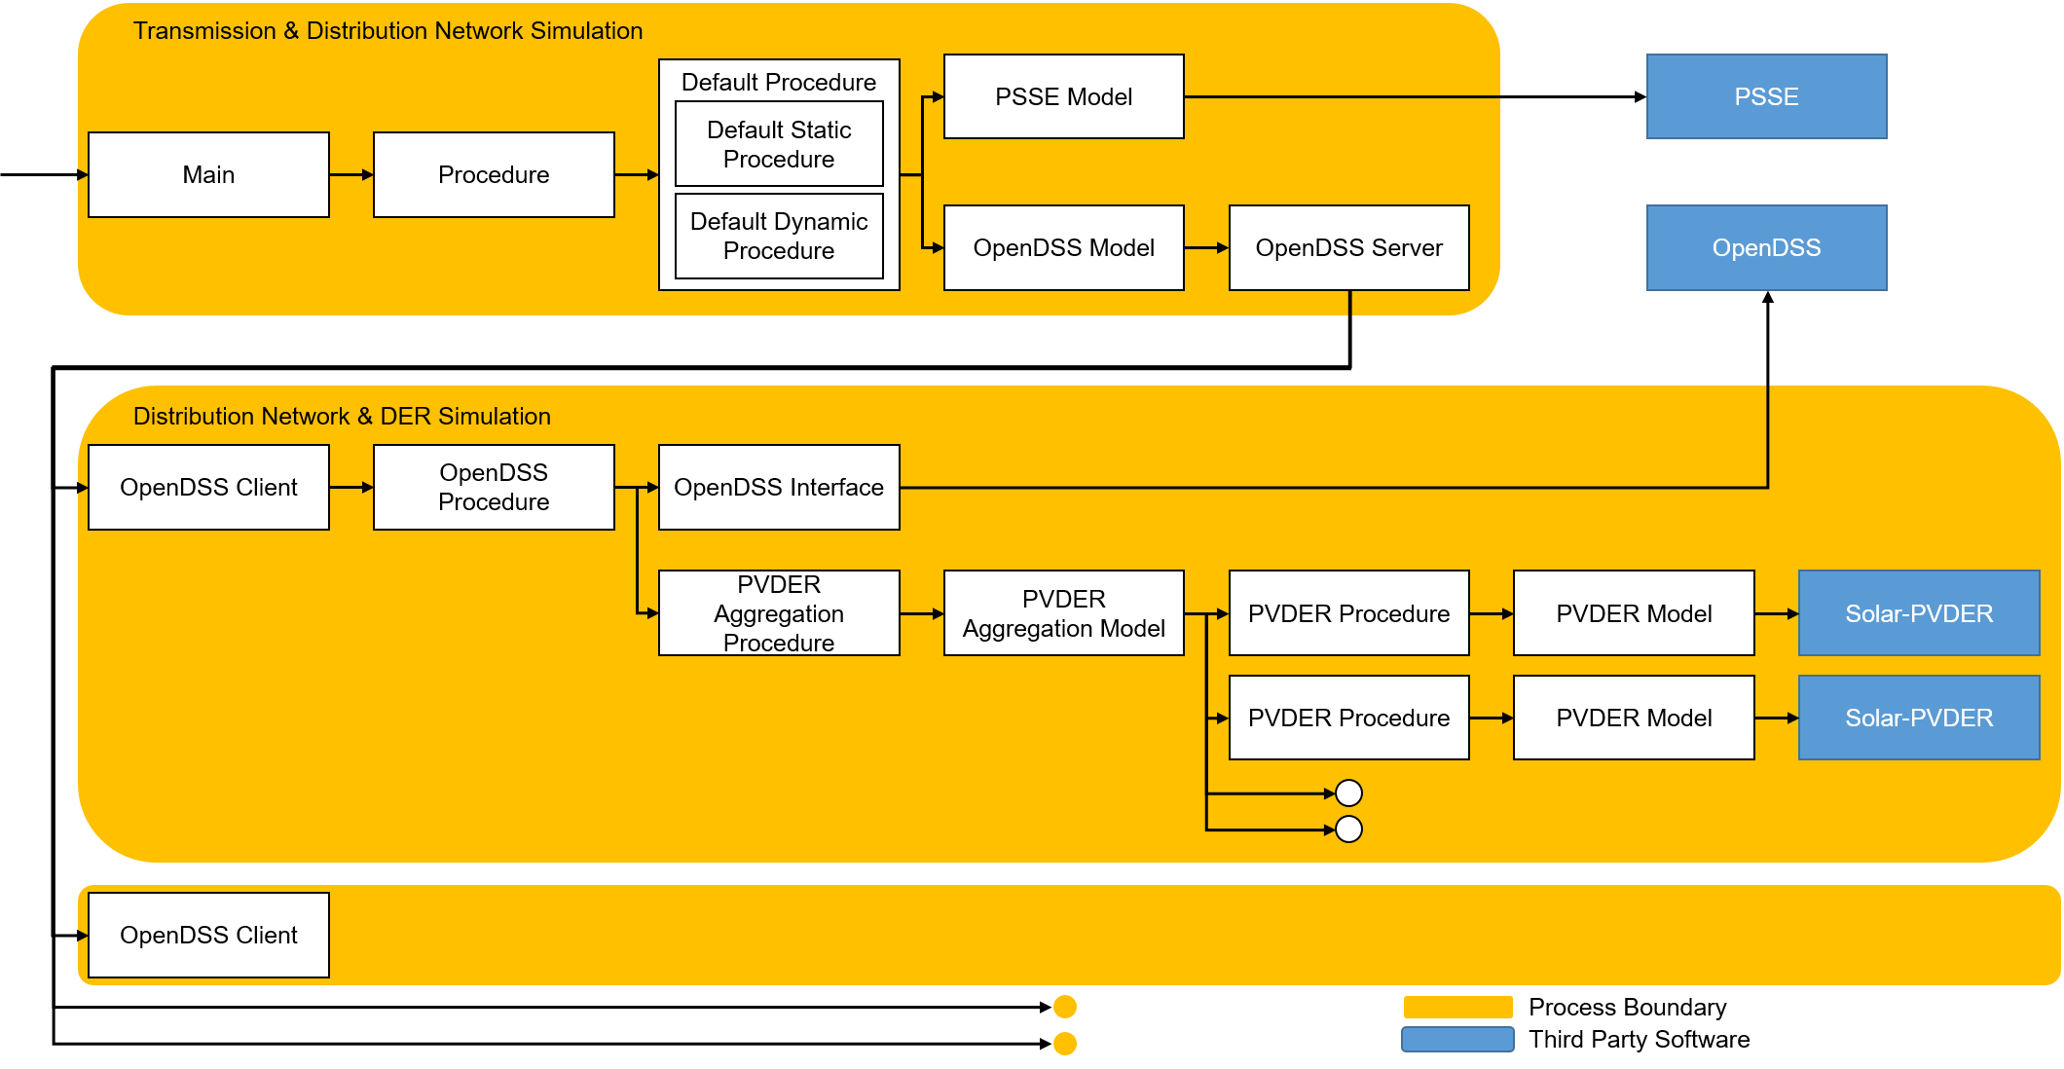

Fig. 2. Detailed simulation architecture

The simulation is managed by procedures for each model. The procedures define the simulation orders between multiple simulation objects. Each model represent a single simulation object that represents a specific component of T&D system. The procedures have hierarchical one-to-many relationships. The simulation type procedures are connected to multiple OpenDSS procedures via OpenDSS model, and the OpenDSS procedures are connected to multiple PVDER procedures via PVDER Aggregation model.

### Sequence of operations

The sequence of operations within the program is listed below:

1. Open TCP server sockets
2. Create a transmission network object
3. Create transmission network bus objects
4. Create distribution network objects
5. Create sub-processes
6. Establish TCP connection
7. Connect to OpenDSS via COM-Interface
8. Run the distribution network simulation

# Example 1: Test Example with Single Distribution System comparing the impact of DER Tripping with DER riding through fault.

In this test, the TDcosim tool is tested for three different scenarios: 1. With distribution system connected to Bus 1 of 118 bus system where the DER penetration level is 10% of distribution system load and the DERs connected in the distribution system TRIP instantaneously below level “0” voltage threshold. The DER configuration used for this case is shown below:

```json  
 "manualFeederConfig":{  
 "nodes": [  
 {  
 "nodenumber": 1,  
 "filePath": ["\\SampleData\\DNetworks\\123Bus\\case123ZIP.dss"],  
 "solarFlag":1,   
 "DERParameters":{  
 "default":{  
 "solarPenetration":0.0,   
 "powerRating": 50,  
 "VrmsRating":174,  
 "LVRT":"1":{"V_threshold":0.88,  
 "t_threshold":0.016,  
 "mode":"momentary_cessation"  
 }  
 "2":{"V_threshold":0.7,  
 "t_threshold":0.016,  
 "mode":"momentary_cessation"  
 }  
 }  
 }}  
 }  
 ]  
 }  
 ```

The DER trip settimg used for this case is shown in Figure A below.

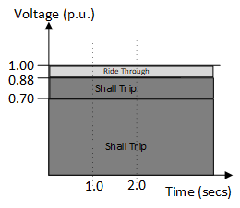 Figure A: DER operational settings curve for the instantaneous trip settings.

1. With distribution system connected to Bus 1 of 118 bus system where the DER penetration level is 10% of distribution system load and the DERs connected in the distribution system Ride Through the fault causing voltage sag below level “0” voltage threshold. The DER configuration used for this case is shown below:

"manualFeederConfig":{  
 "nodes": [  
 {  
 "nodenumber": 1,  
 "filePath": ["\\SampleData\\DNetworks\\123Bus\\case123ZIP.dss"],  
 "solarFlag":1,   
 "DERParameters":{  
 "default":{  
 "solarPenetration":0.1,   
 "powerRating": 50,  
 "VrmsRating":174,  
 "LVRT":"1":{"V_threshold":0.88,  
 "t_threshold":2.0,  
 "mode":"mandatory_operation"  
 }  
 }  
 }}  
 }  
 ]  
 }

The DER trip settimg used for this case is shown in Figure B below.

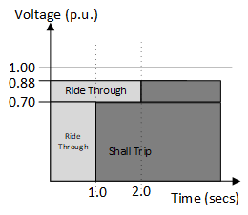 Figure B: DER operational settings curve for the DER ride through settings.

1. With distribution system connected to Bus 1 of 118 bus system without any DERs on the distribution system. The DER configuration used for this case is shown below:

* “manualFeederConfig”:{ “nodes”: [ { “nodenumber”: 1, “filePath”: [“\SampleData\DNetworks\123Bus\case123ZIP.dss”], “solarFlag”:1,  
  “DERParameters”:{ “default”:{ “solarPenetration”:0.0 } }} } ] }

A fault is applied in bus 5 of the T-system which causes a lower voltage sag in the D-system connected in bus 1. The simulation configuration to apply fault on bus 5 is shown below.

"simulationConfig":{  
 "simType":"dynamic",  
 "dynamicConfig":{  
 "events":{  
 "1":{  
 "time":0.5,  
 "type":"faultOn",  
 "faultBus":5,  
 "faultImpedance":[0.0,-2.0E11]  
 },  
 "2":{  
 "type":"faultOff",  
 "time":0.6,  
 "faultBus":5  
 },  
 "3":{  
 "type":"simEnd",  
 "time":10.0  
 }  
 }  
 },  
 "staticConfig":{  
 "loadShape": [1,1.1,1.2,0.9]  
 },  
 "protocol":"loose_coupling"  
},  
"outputConfig":{  
 "outputfilename": "output.csv",  
 "type": "csv"  
}

}

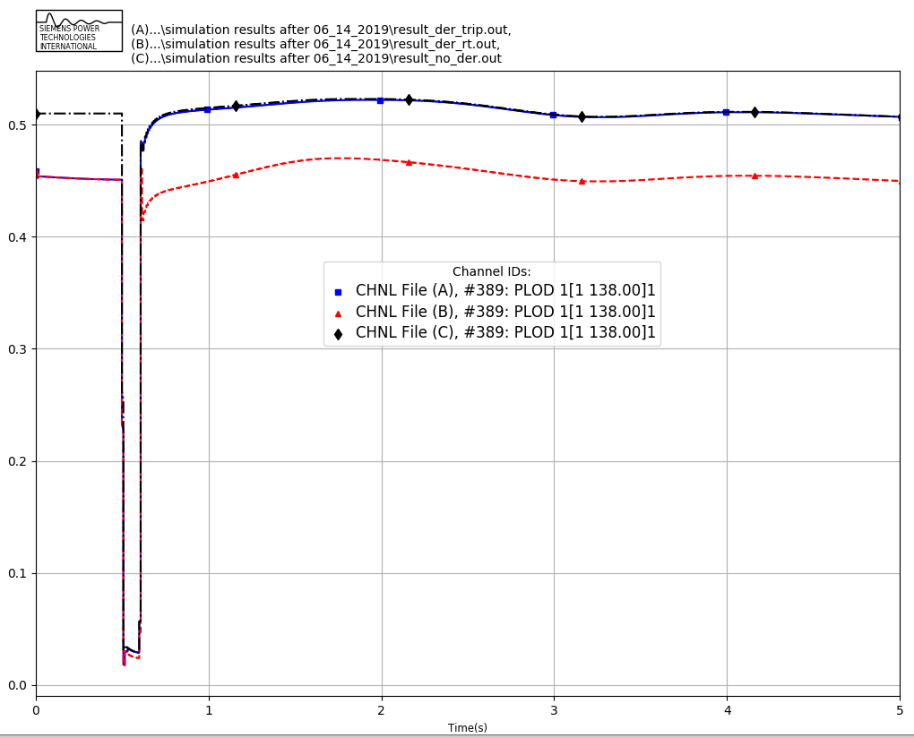 Figure 1: Active component of load as observed at the T-bus for the cases considered. (A): 10% DER penetration with DER TRIP Settings, (B): 10% DER penetration with DER RT Settings and (C) 0% DER penetration.

Figure 1 above compares the active power component of the load observed in the T-bus for the three cases considered. It can be observed that case C, without DER on the distribution starts off with higher initial net load. Case A and Case B has a lower initial net load due to the DER connected in the distribution system masking the portion of total load in the system. Here net load is defined as the difference of the total load in the distribution system and the DER connected in the distribution system.

For the DER trip case, Case A, it can be observed that the net load observed in the bus increases to a value equal to the case without any DERs in the system, case C, which is an expected response of the system as net load in the T-bus reverts back to the total load as DER in the distribution system trips. A similar response can be observed for the reactive power component of the net load in the system as shown in Figure 2, which shows that the net reactive power equals the total reactive power as when DER trips, the system reverts back to the operational condition before DER connection in the system.

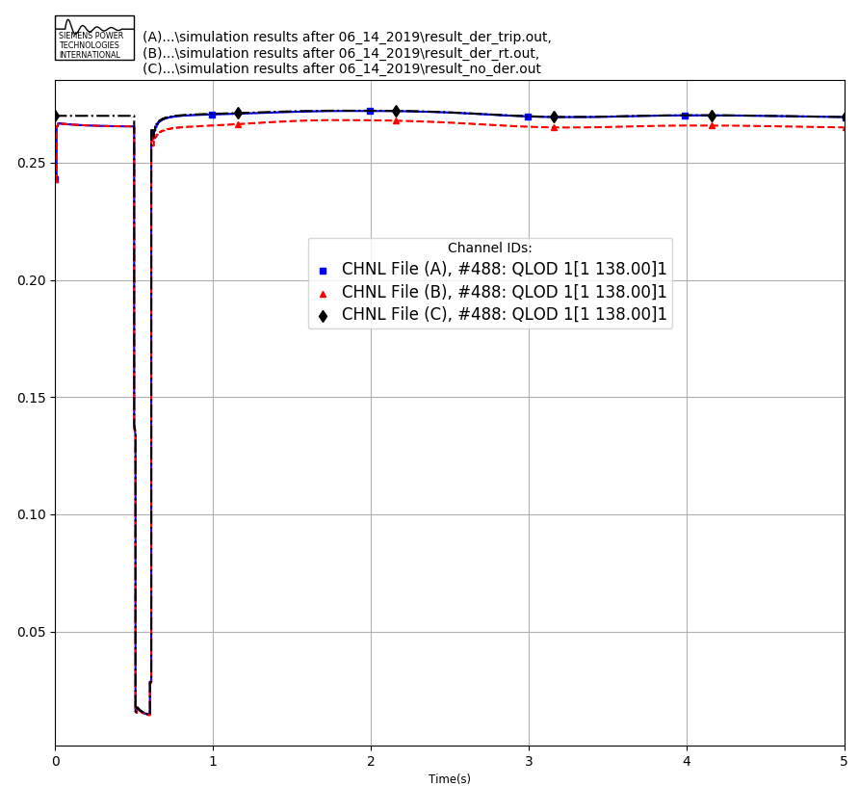 Figure 2: Reactive component of load as observed at the T-bus for the cases considered. (A): 10% DER penetration with DER TRIP Settings, (B): 10% DER penetration with DER RT Settings and (C) 0% DER penetration.

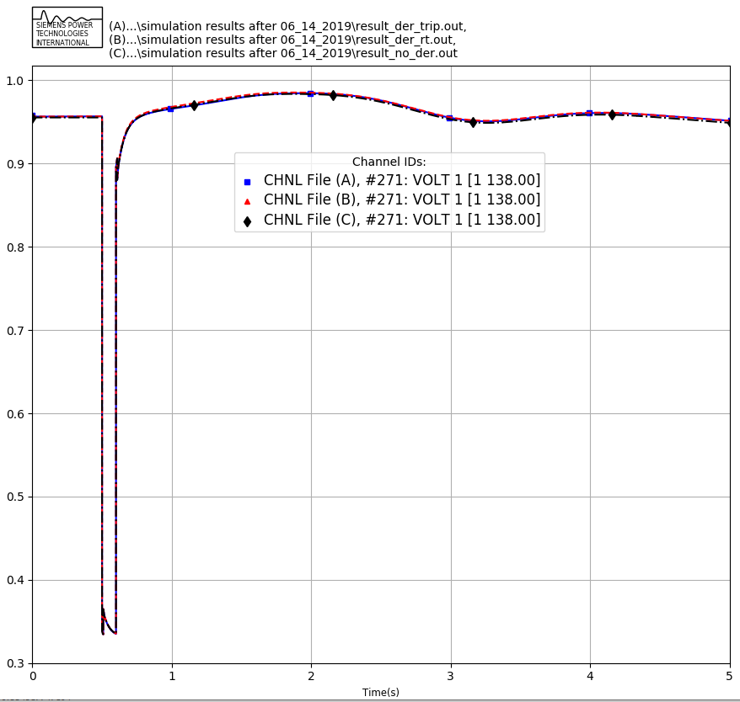 Figure 3: T-bus 1 voltage comparison for the cases considered. (A): 10% DER penetration with DER TRIP Settings, (B): 10% DER penetration with DER RT Settings and (C) 0% DER penetration.

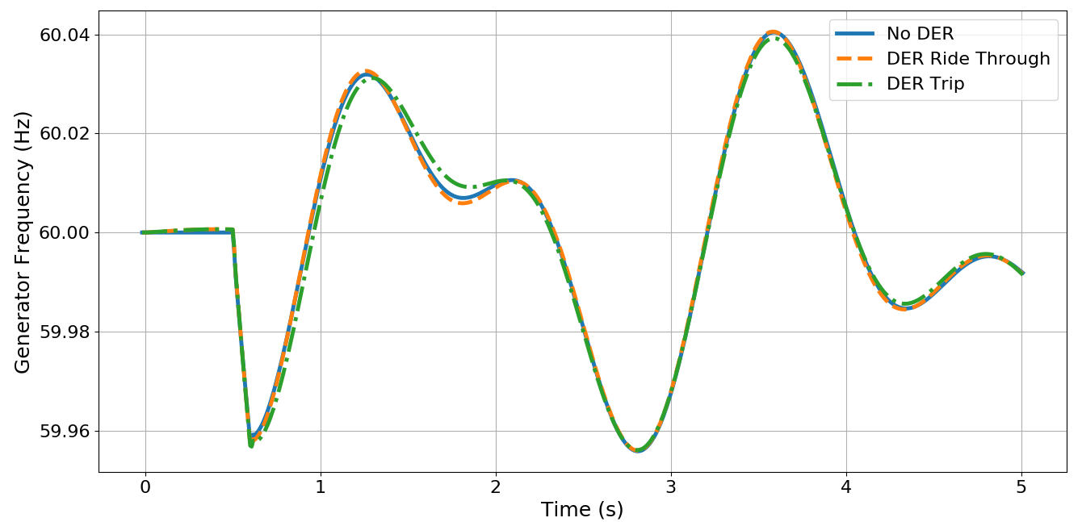 Figure 4: Generator 1 Speed Comparison for the different cases considered.

Figure 3 shows the transmission bus voltage for bus 1 for the three cases considered. It can be observed that the voltage at bus 1 is same for all the cases considered. This is because for this case bus 1, where distribution system is connected, also had a synchronous generator connected to it which was regulating the bus voltage. Figure 4 shows the generator rotor frequency for the cases considered. It can be observed that the frequency nadir following system fault close to the fault location is lower for the case with DER trip. More tests with more distribution system and DERs should be performed to properly study the impact of DERs on system frequency response.

# Example 1: Test of system state initialization with TDcoSim tool

In this test study, different penetration level of DERs within one distribution system connected to a transmission bus is studied. The purpose of this study is to test the ability of the tool to properly initialize the states of all the dynamic components of the system. Without any disturbance introduced in the system through changes in operating points or faults, it is expected that the responses of the various components in the system be a flat profile if the state of the various components are properly initialized i.e. all the variables should have a constant value throughout the duration of simulation.

The DER configuration used in this case is as follows, where the “solarPenetration” was varied with 10% increment for each of the cases:

"manualFeederConfig":{  
 "nodes": [  
 {  
 "nodenumber": 1,  
 "filePath": ["\\SampleData\\DNetworks\\123Bus\\case123ZIP.dss"],  
 "solarFlag":1,   
 "DERParameters":{  
 "default":{  
 "solarPenetration":0.0,   
 "powerRating": 50,  
 "VrmsRating":174   
 }}  
 }  
 ]  
 }

The study was done with 123 node distribution system connected to bus 1 of the IEEE 118 bus system and five different DER penetration level relative to load in bus 1 ranging from 0 to 40% with the step increment of 10% is studied.

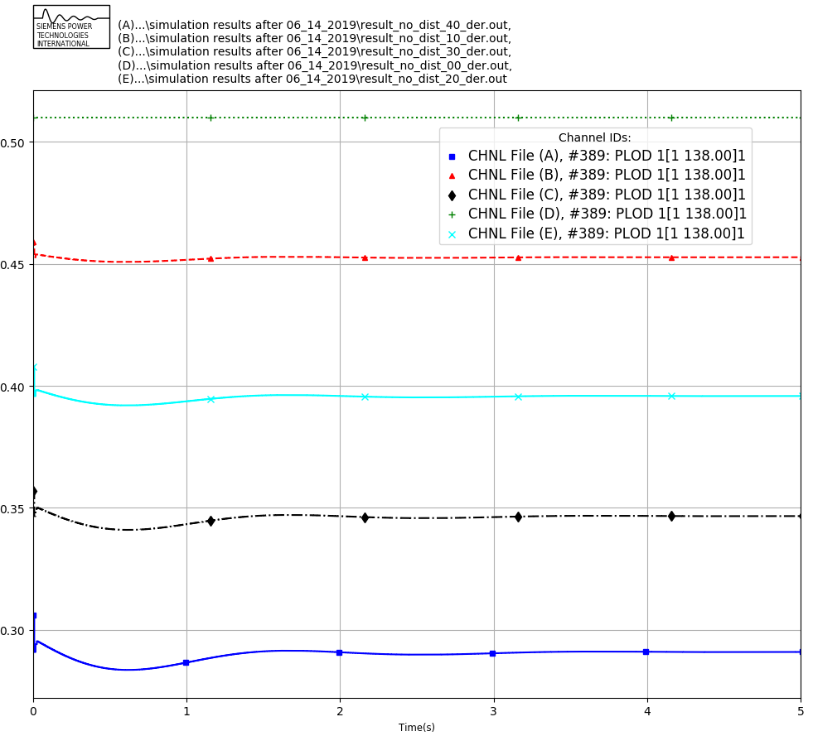

Pload comparison

Figure 6: Active Power observed in bus 1 for the different cases considered (Green: No DER, Red: 10% DER, Cyan: 20% DER, Black: 30% DER, Blue: 40% DER).

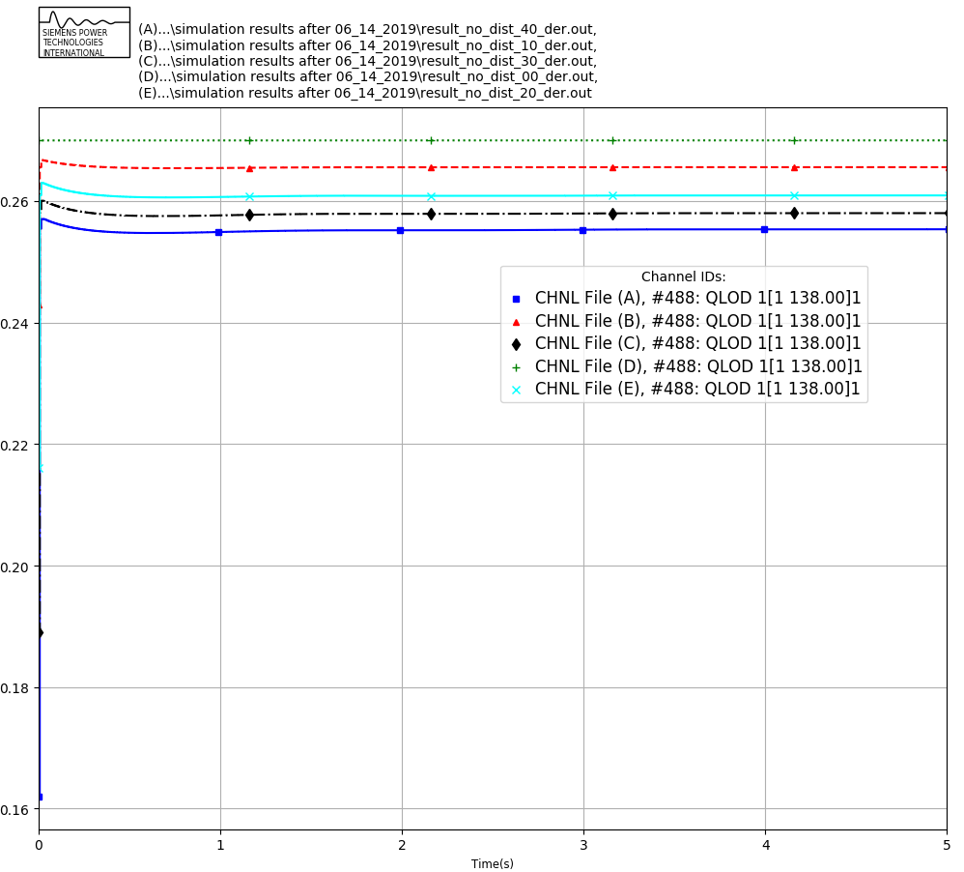

Qload comparison

Figure 7: Reactive power observed in bus 1 for the different cases considered. (Green: No DER, Red: 10% DER, Cyan: 20% DER, Black: 30% DER, Blue: 40% DER)

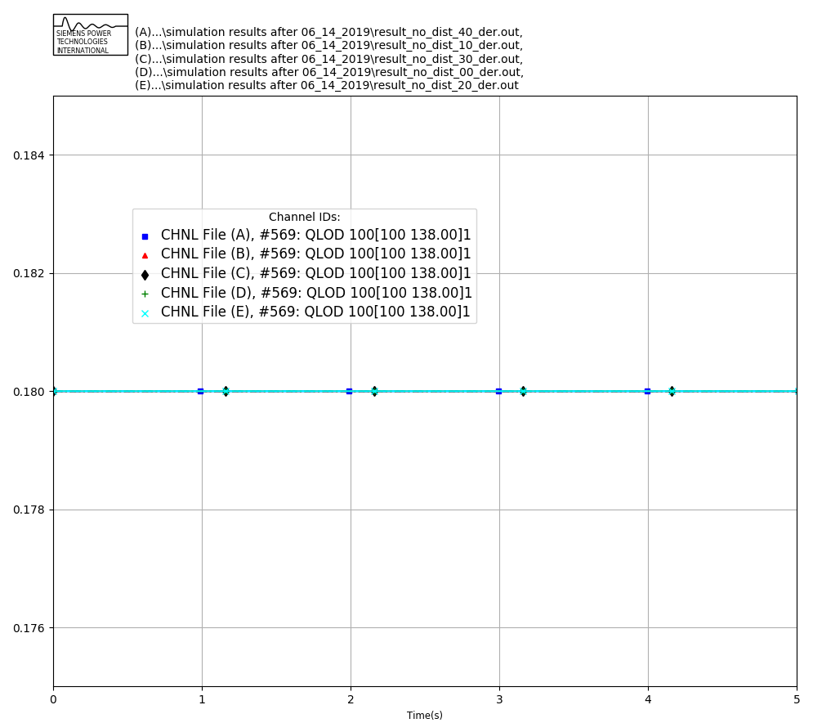

Qload comparison

Figure 8: Reactive power observed in bus 100 for the different cases considered. (Green: No DER, Red: 10% DER, Cyan: 20% DER, Black: 30% DER, Blue: 40% DER)

Figure 6 shows the flat start performance of the TDcosim tool for different penetration level of DER. It can be observed that with the DER added into the test system, TDcosim tool takes couple of secs to reach the steady state active power consumption at the DER connected bus. Also, note that the settling value of the net active power is slightly below to the calculated net load power based on DER penetration. One of the reason for this is that the addition of DER within the distribution feeder doesn’t amount to an exact amount of net load drop within the distribution feeder. This depends on the various factors like power output of the DER, location of DER, nature of the loads modelled and so on. We are working to have the net load initialized properly.

Figure 7 shows the reactive power observed in bus 1 for the different cases considered. It can be observed that the reactive power consumed at the DS & DER connected bus decreases as DER penetration increases. Figure 8 shows no change in the reactive power for a random bus (bus 100).

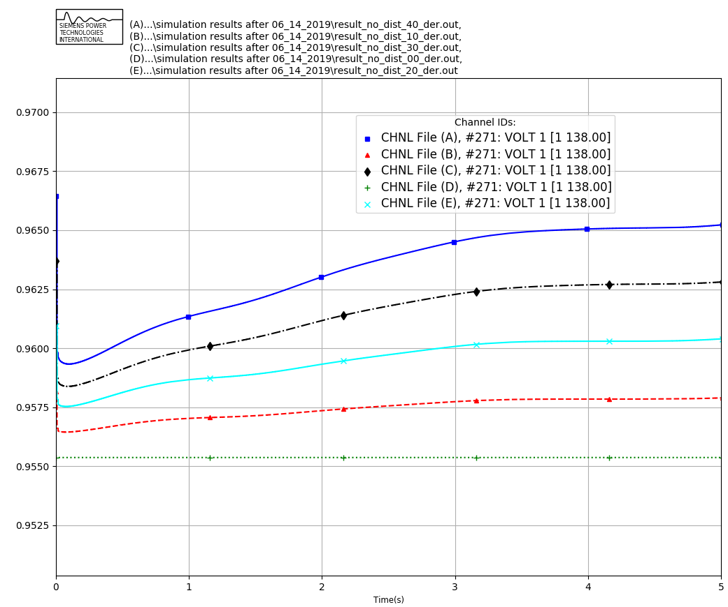

Voltage_1 comparison

Figure 9: Voltage profile observed in bus 1 for the different cases considered. (Green: No DER, Red: 10% DER, Cyan: 20% DER, Black: 30% DER, Blue: 40% DER)

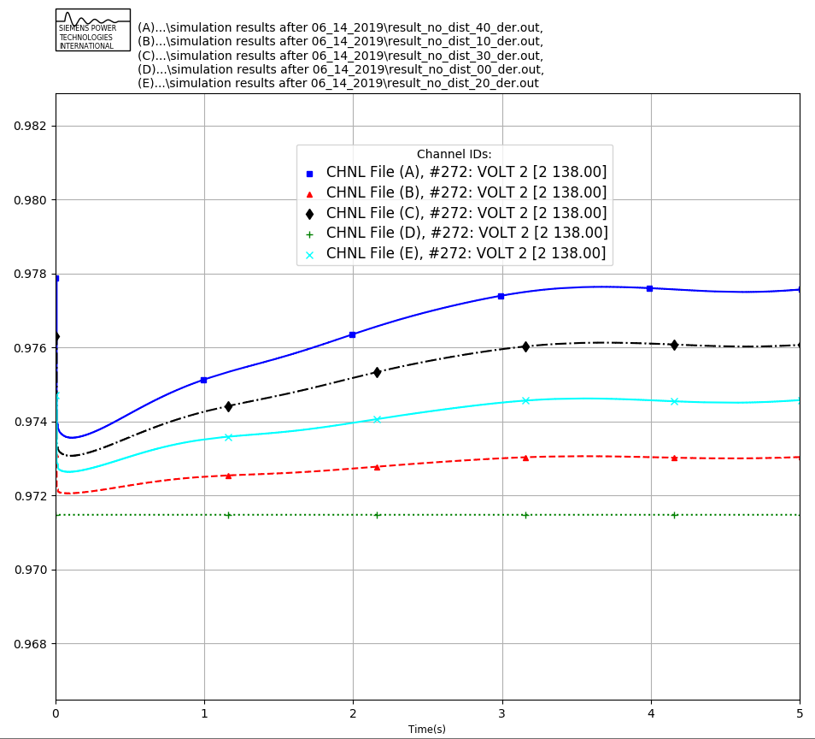

Voltage_2 comparison

Figure 10: Voltage profile observed in bus 2 for the different cases considered. (Green: No DER, Red: 10% DER, Cyan: 20% DER, Black: 30% DER, Blue: 40% DER)

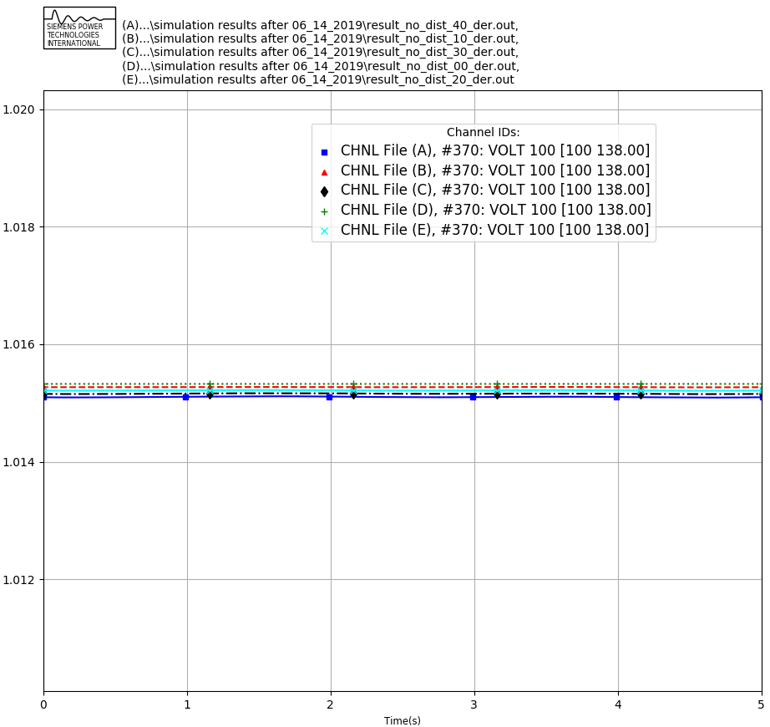

Voltage_100 comparison

Figure 11: Voltage profile observed in bus 100 for the different cases considered. (Green: No DER, Red: 10% DER, Cyan: 20% DER, Black: 30% DER, Blue: 40% DER)

Figure 9 shows the voltage plot for bus 1 for the different cases considered. It can be observed that the with the DER added in the system, the bus voltage settles at a higher steady state voltage and it takes almost 4 secs for the system to reach a steady state. Similar settling time were observed in the buses nearby the DER connected buses as shown in Figure 10.

Such differences in settling time were not observed in electrically distant buses as shown in Figure 11, even though steady state differences were observed between different cases.

Figure 12 shows the generator speed profile for the base case scenario without any DER penetration. It can be observed that the system frequency is initialized at exactly 60 Hz and stays constant at 60 Hz throughout the simulation. Figure 13 shows the generator speed profile for the 40 percent DER penetration case. It can be observed that the generator speed has few oscillations that dies down slowly over time. The oscillations are due to the mismatch in the calculation of initial conditions for load and generation.

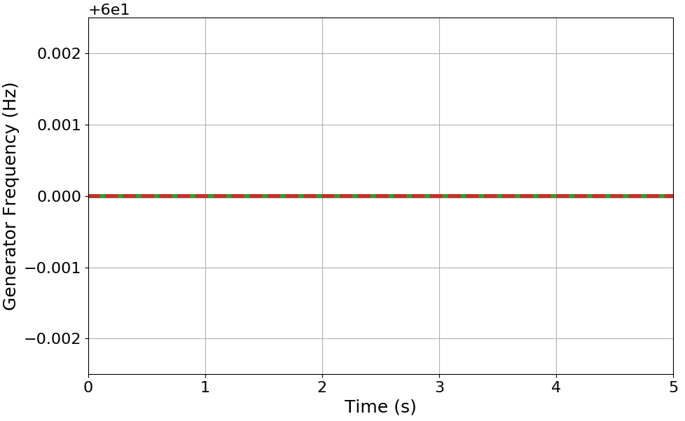

frequency_00 plot

Figure 11: Frequency plot for the system generators for the basecase with zero DER penetration.

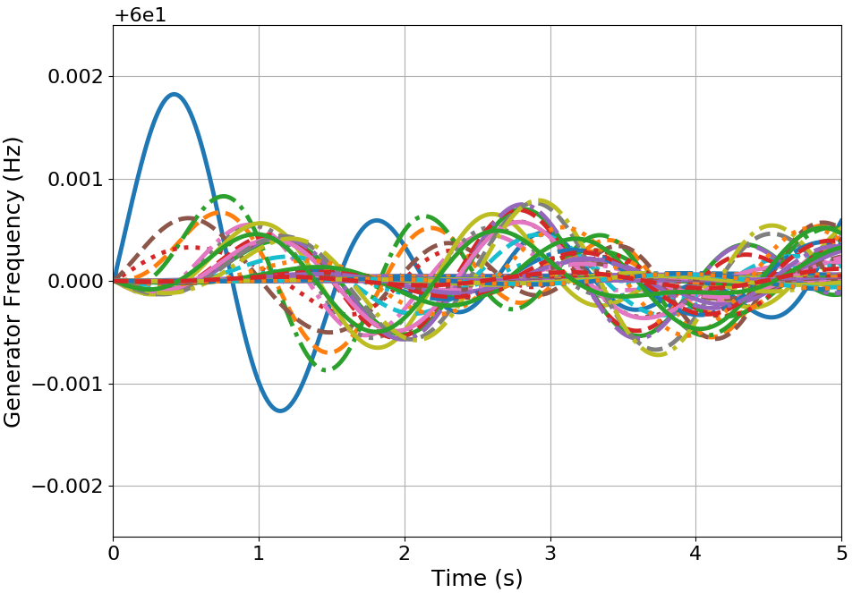

frequency_40 plot

Figure 11: Frequency plot for the system generators for the case with 40 percent DER penetration.

Please note that the tool takes few simulation seconds for the system to reach a steady state solution for the dynamic cases. The developers are working on the initialization of system dynamic states so as to obtain a steady state solution from time t=0+. So for the current version of the tool, to study the system dynamics change of operating points and disturbances are applied only after the system reaches a certain steady state threshold i.e. at least 0.5 seconds.

# Example 3: Test Example with Two Distribution System comparing the impact of DER Tripping with DER riding through fault.

In this test, the TDcosim tool is tested for three different scenarios: 1. With distribution system connected to Bus 2 and Bus 3 of 118 bus system where the DER penetration level is 10% of distribution system load and the DERs connected in the distribution system TRIP instantaneously below level “0” voltage threshold. The DER configuration used for this case is shown below (for bus number 2):

```json  
 "manualFeederConfig":{  
 "nodes": [  
 {  
 "nodenumber": 1,  
 "filePath": ["\\SampleData\\DNetworks\\123Bus\\case123ZIP.dss"],  
 "solarFlag":1,   
 "DERParameters":{  
 "default":{  
 "solarPenetration":0.1,   
 "powerRating": 50,  
 "VrmsRating":174,  
 "LVRT":"0":{"V_threshold":0.88,  
 "t_threshold":2.0,  
 "mode":"mandatory_operation"  
 },  
 "1":{"V_threshold":0.7,  
 "t_threshold":1.0,  
 "mode":"mandatory_operation"  
 }  
 }  
 }}  
 }  
 ]  
 }  
 ```

Same configuration was used for DERs in bus number 3.

1. With distribution system connected to Bus 2 and Bus 3 of 118 bus system where the DER penetration level is 10% of distribution system load and the DERs connected in the distribution system Ride Through the fault causing voltage sag below level “0” voltage threshold. The DER configuration used for this case is shown below (for bus number 3):

"manualFeederConfig":{  
 "nodes": [  
 {  
 "nodenumber": 1,  
 "filePath": ["\\SampleData\\DNetworks\\123Bus\\case123ZIP.dss"],  
 "solarFlag":1,   
 "DERParameters":{  
 "default":{  
 "solarPenetration":0.1,   
 "powerRating": 50,  
 "VrmsRating":174,  
 "LVRT":"0":{"V_threshold":0.88,  
 "t_threshold":2.0,  
 "mode":"mandatory_operation"  
 },  
 "1":{"V_threshold":0.7,  
 "t_threshold":1.0,  
 "mode":"mandatory_operation"  
 }  
 }  
 }}  
 }  
 ]  
 }

Same configuration was used for DERs in bus number 2.

1. With distribution system connected to Bus 2 and Bus 3 of 118 bus system without any DERs on the distribution system. The DER configuration used for this case is shown below:

"manualFeederConfig":{  
 "nodes": [  
 {  
 "nodenumber": 2,  
 "filePath": ["\\SampleData\\DNetworks\\123Bus\\case123ZIP.dss"],  
 "solarFlag":1,   
 "DERParameters":{  
 "default":{  
 "solarPenetration":0.0,   
 }  
 }}  
 },  
 {  
 "nodenumber": 3,  
 "filePath": ["\\SampleData\\DNetworks\\123Bus\\case123ZIP.dss"],  
 "solarFlag":1,   
 "DERParameters":{  
 "default":{  
 "solarPenetration":0.0,   
 }  
 }}  
 }  
 ]  
 }

The disturbance applied in this case is the fault on bus 5. The simulation configuration to apply fault on bus 5 is shown below.

"simulationConfig":{  
 "simType":"dynamic",  
 "dynamicConfig":{  
 "events":{  
 "1":{  
 "time":0.5,  
 "type":"faultOn",  
 "faultBus":5,  
 "faultImpedance":[0.0,-2.0E11]  
 },  
 "2":{  
 "type":"faultOff",  
 "time":0.6,  
 "faultBus":5  
 },  
 "3":{  
 "type":"simEnd",  
 "time":10.0  
 }  
 }  
 },  
 "staticConfig":{  
 "loadShape": [1,1.1,1.2,0.9]  
 },  
 "protocol":"loose_coupling"  
},  
"outputConfig":{  
 "outputfilename": "output.csv",  
 "type": "csv"  
}

}

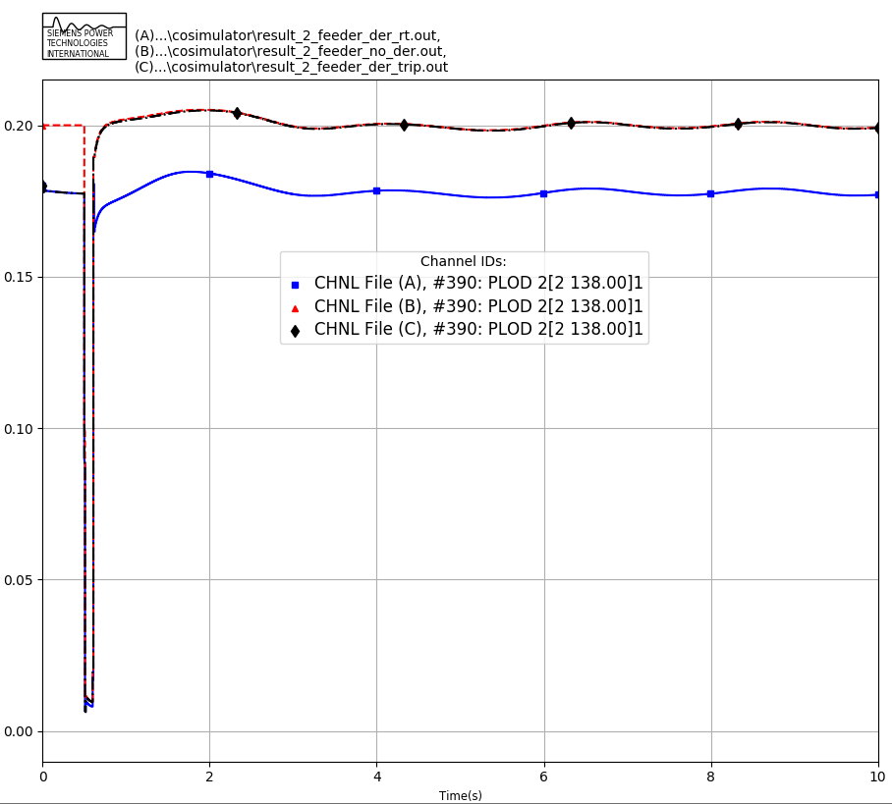 Figure 1: Active component of load as observed at the T-bus ‘2’ for the cases considered. (A): 10% DER penetration with DER RT Settings, (B): 0% DER penetration and (C) 10% DER penetration with DER TRIP Settings.

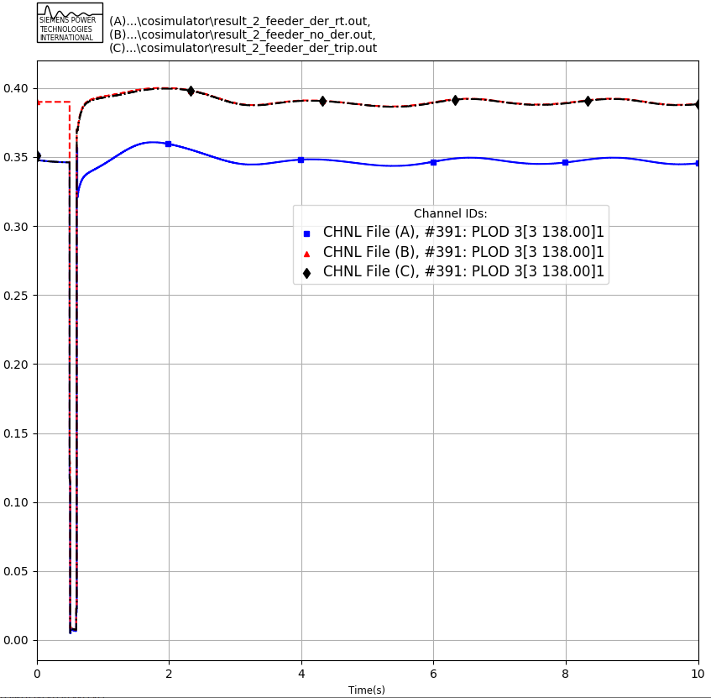 Figure 2: Active component of load as observed at the T-bus ‘3’ for the cases considered. (A): 10% DER penetration with DER RT Settings, (B): 0% DER penetration and (C) 10% DER penetration with DER TRIP Settings.

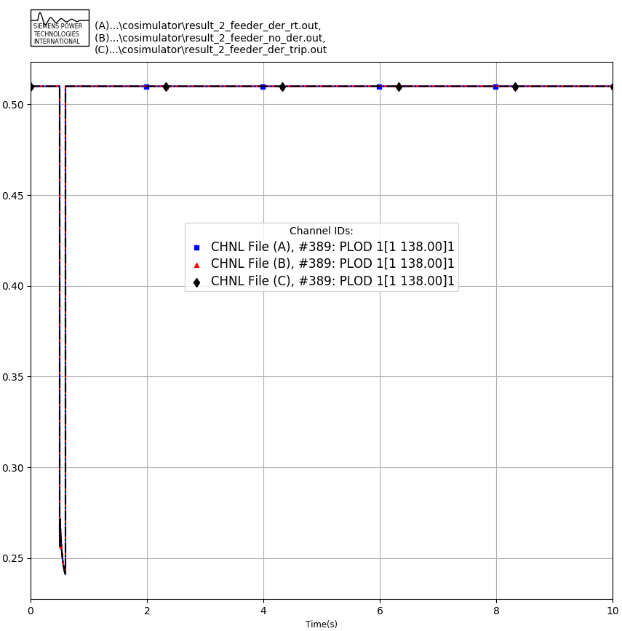 Figure 3: Active component of load as observed at the T-bus ‘1’ for the cases considered. (A): 10% DER penetration with DER RT Settings, (B): 0% DER penetration and (C) 10% DER penetration with DER TRIP Settings.

Figure 1 and 2 above compares the active power component of the load observed in the T-bus (2 and 3 where the DER connected distribution system is modelled) for the three cases considered. It can be observed that case B, without DER on the DS starts off with higher initial net load. Case A and Case C has a lower initial net load due to the DER connected in the distribution system masking the portion of total load in the system. A fault is applied in bus 5 of the T-system which causes a lower voltage sag in the D-system connected in bus 2 and bus 3. For the DER trip case, Case C, it can be observed that the net load observed in the bus increases to a value equal to the case without any DERs in the system, which is an expected response of the system.

A similar response can be observed for the reactive power component of the net load for bus ‘2’ and bus ‘3’ in the system as shown in Figure 4 and 5. In case of reactive power, the offset in reactive power with DERs connected was due to the differences in the load flow within the distribution system due to DER interconnection.

Figure 3 compares the active power component of the load observed in bus 1 of the T-system, as no DER connected distribution system was modelled for this bus, the load profile for all the three cases considered are the same.

A similar response can be observed in Figure 6 for reactive power component of net load connected at bus ‘1’ as no distribution system was connected in bus 1.

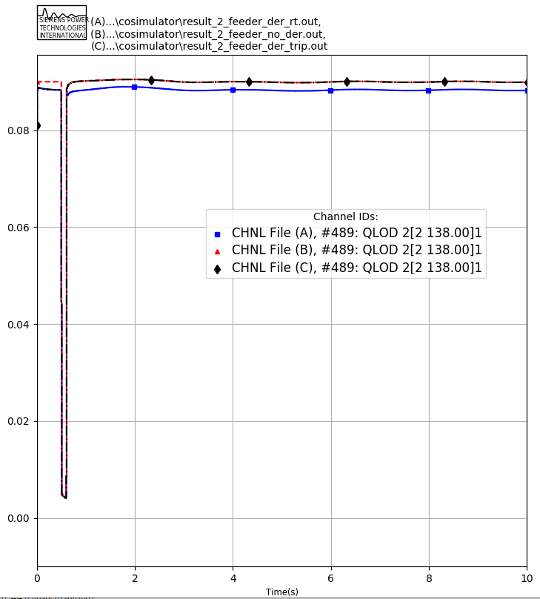

Qload comparison

Figure 4: Reactive component of load as observed at the T-bus ‘2’ for the cases considered. (A): 10% DER penetration with DER RT Settings, (B): 0% DER penetration and (C) 10% DER penetration with DER TRIP Settings.

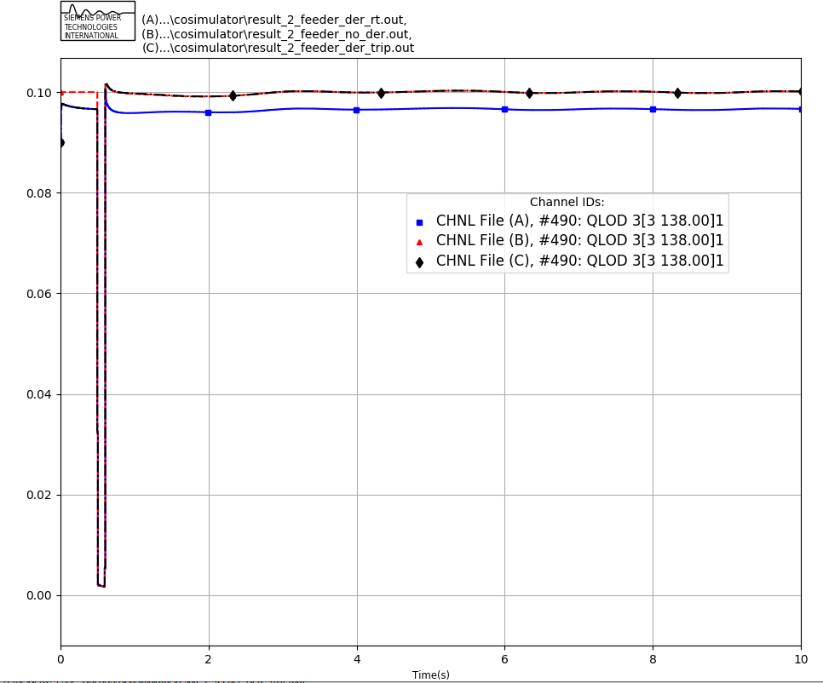 Figure 5: Reactive component of load as observed at the T-bus ‘3’ for the cases considered. (A): 10% DER penetration with DER RT Settings, (B): 0% DER penetration and (C) 10% DER penetration with DER TRIP Settings.

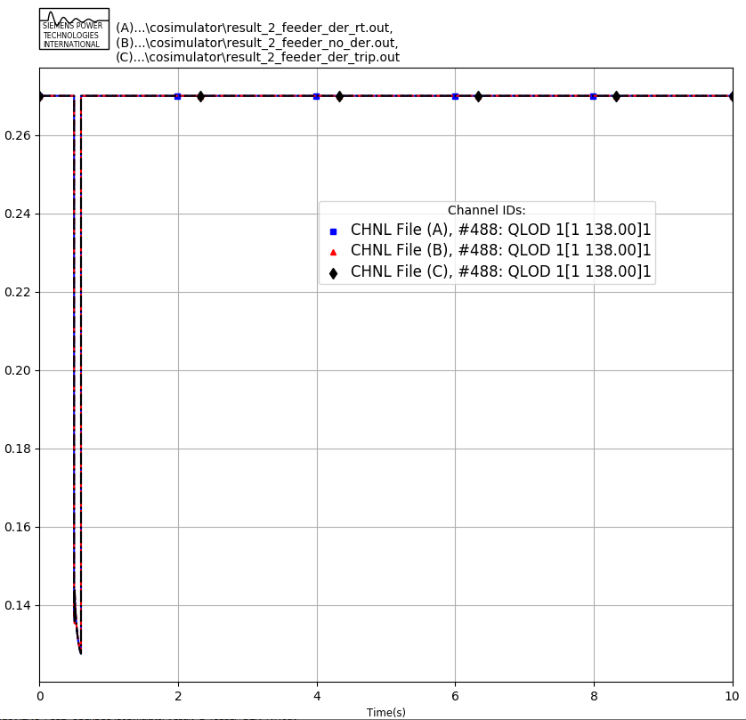 Figure 6: Reactive component of load as observed at the T-bus ‘1’ for the cases considered. (A): 10% DER penetration with DER RT Settings, (B): 0% DER penetration and (C) 10% DER penetration with DER TRIP Settings.

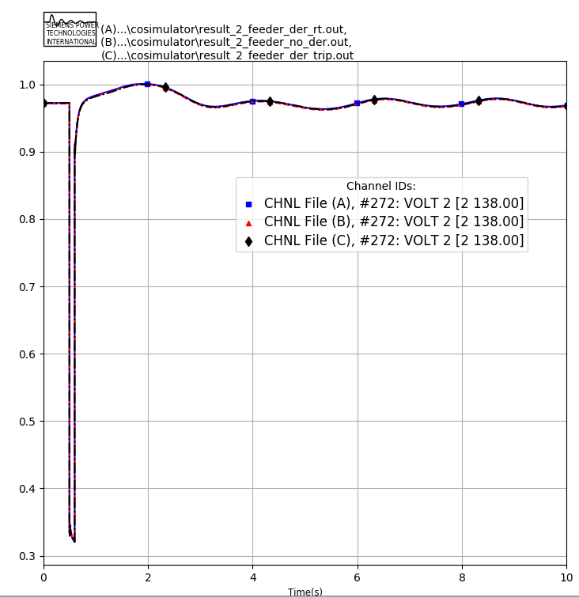

volt comparison

Figure 7: Voltage of bus 2 for the cases considered. (A): 10% DER penetration with DER RT Settings, (B): 0% DER penetration and (C) 10% DER penetration with DER TRIP Settings.

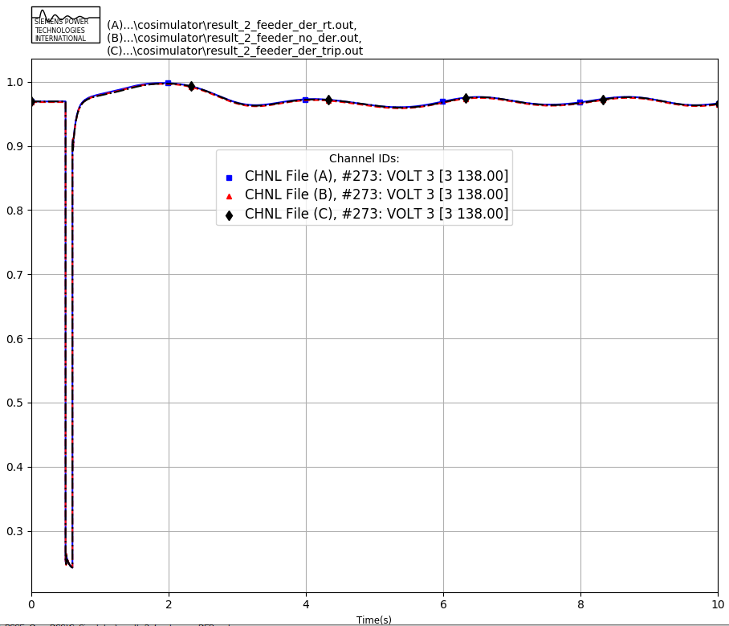 Figure 8: Voltage of bus 3 for the cases considered. (A): 10% DER penetration with DER RT Settings, (B): 0% DER penetration and (C) 10% DER penetration with DER TRIP Settings.

Figure 7 and Figure 8 shows the transmission bus voltage for bus 2 and bus 3 respectively, for the three cases considered. It can be observed that the voltage at bus 2 and bus 3 is almost the same for all the cases considered which could be associated with the low DER penetration and effect of nearby synchronous machine’s voltage regulation.

More studies with higher DER penetration level with distribution system in large number of buses are also conducted and discussed in following subsections.

# Example 4: Test Example with Eight Distribution System comparing the impact of DER Tripping with DER riding through fault.

In this test, the TDcoSim tool is tested for three different scenarios: 1. With distribution system connected to Bus 2, 3, 7, 11,13,14,16, and 117 of 118 bus system where the DER penetration level is 10% of distribution system load and the DERs connected in the distribution system TRIP instantaneously below “0” voltage level. The DER configuration used for this case is shown below (for bus number 2):

```json  
 "manualFeederConfig":{  
 "nodes": [  
 {  
 "nodenumber": 1,  
 "filePath": ["\\SampleData\\DNetworks\\123Bus\\case123ZIP.dss"],  
 "solarFlag":1,   
 "DERParameters":{  
 "default":{  
 "solarPenetration":0.1,   
 "powerRating": 50,  
 "VrmsRating":174,  
 "LVRT":"1":{"V_threshold":0.88,  
 "t_threshold":2.0,  
 "mode":"momentary_cessation"  
 }  
 }  
 }  
 }   
 ]  
 }  
 ```

Same configuration was used for DERs in distribution system in bus number Bus 3,7,11,13,14,16 and 117.

1. With distribution system connected to Bus 2,3,7,11,13,14,16 and 117 of 118 bus system where the DER penetration level is 10% of distribution system load and the DERs connected in the distribution system Ride Through the fault causing voltage sag below level “1” voltage threshold. The DER configuration used for this case is shown below (for bus number 3):

"manualFeederConfig":{  
 "nodes": [  
 {  
 "nodenumber": 1,  
 "filePath": ["\\SampleData\\DNetworks\\123Bus\\case123ZIP.dss"],  
 "solarFlag":1,   
 "DERParameters":{  
 "default":{  
 "solarPenetration":0.1,   
 "powerRating": 50,  
 "VrmsRating":174,  
 "LVRT":"1":{"V_threshold":0.88,  
 "t_threshold":2.0,  
 "mode":"mandatory_operation"  
 }  
 }  
 }  
 }   
 ]  
 }

Same configuration was used for DERs in distribution system in bus number Bus 3,7,11,13,14,16 and 117.

1. With distribution system connected to Bus 2,3,7,11,13,14,16 and 117 of 118 bus system without any DERs on the distribution system. The DER configuration used for this case is shown below:

* "manualFeederConfig":{  
   "nodes": [  
   {  
   "nodenumber": 1,  
   "filePath": ["\\SampleData\\DNetworks\\123Bus\\case123ZIP.dss"],  
   "solarFlag":1,   
   "DERParameters":{  
   "default":{  
   "solarPenetration":0.0  
   }  
   }  
   }   
   ]  
   }

Same configuration was used for DERs in distribution system in bus number Bus 3,7,11,13,14,16 and 117.

The disturbance applied in this case is the fault on bus 5. The simulation configuration to apply fault on bus 5 is shown below.

"simulationConfig":{  
 "simType":"dynamic",  
 "dynamicConfig":{  
 "events":{  
 "1":{  
 "time":0.5,  
 "type":"faultOn",  
 "faultBus":5,  
 "faultImpedance":[0.0,-2.0E11]  
 },  
 "2":{  
 "type":"faultOff",  
 "time":0.6,  
 "faultBus":5  
 },  
 "3":{  
 "type":"simEnd",  
 "time":10.0  
 }  
 }  
 },  
 "staticConfig":{  
 "loadShape": [1,1.1,1.2,0.9]  
 },  
 "protocol":"loose_coupling"  
},  
"outputConfig":{  
 "outputfilename": "output.csv",  
 "type": "csv"  
}

}

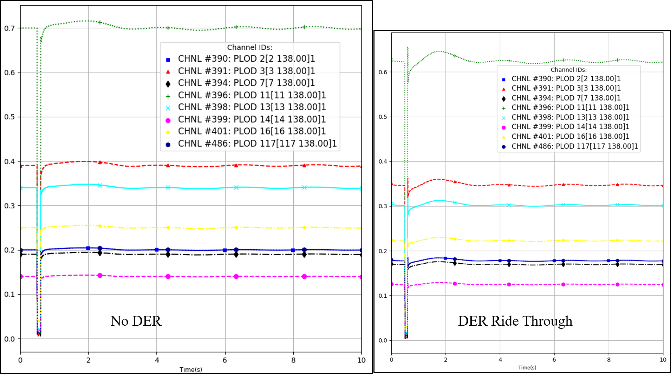 Figure 1: Active component of load as observed at the distribution system connected T-buses for the case with no DER and with DER with Ride Through Settings.

Figure 1 shows that the with the DER added into the distribution system connected at various buses, the net load on those buses decreases. The ride through settings of the DER is working as its supposed on the TDcoSim tool as the net load of the bus before and after the fault is same.

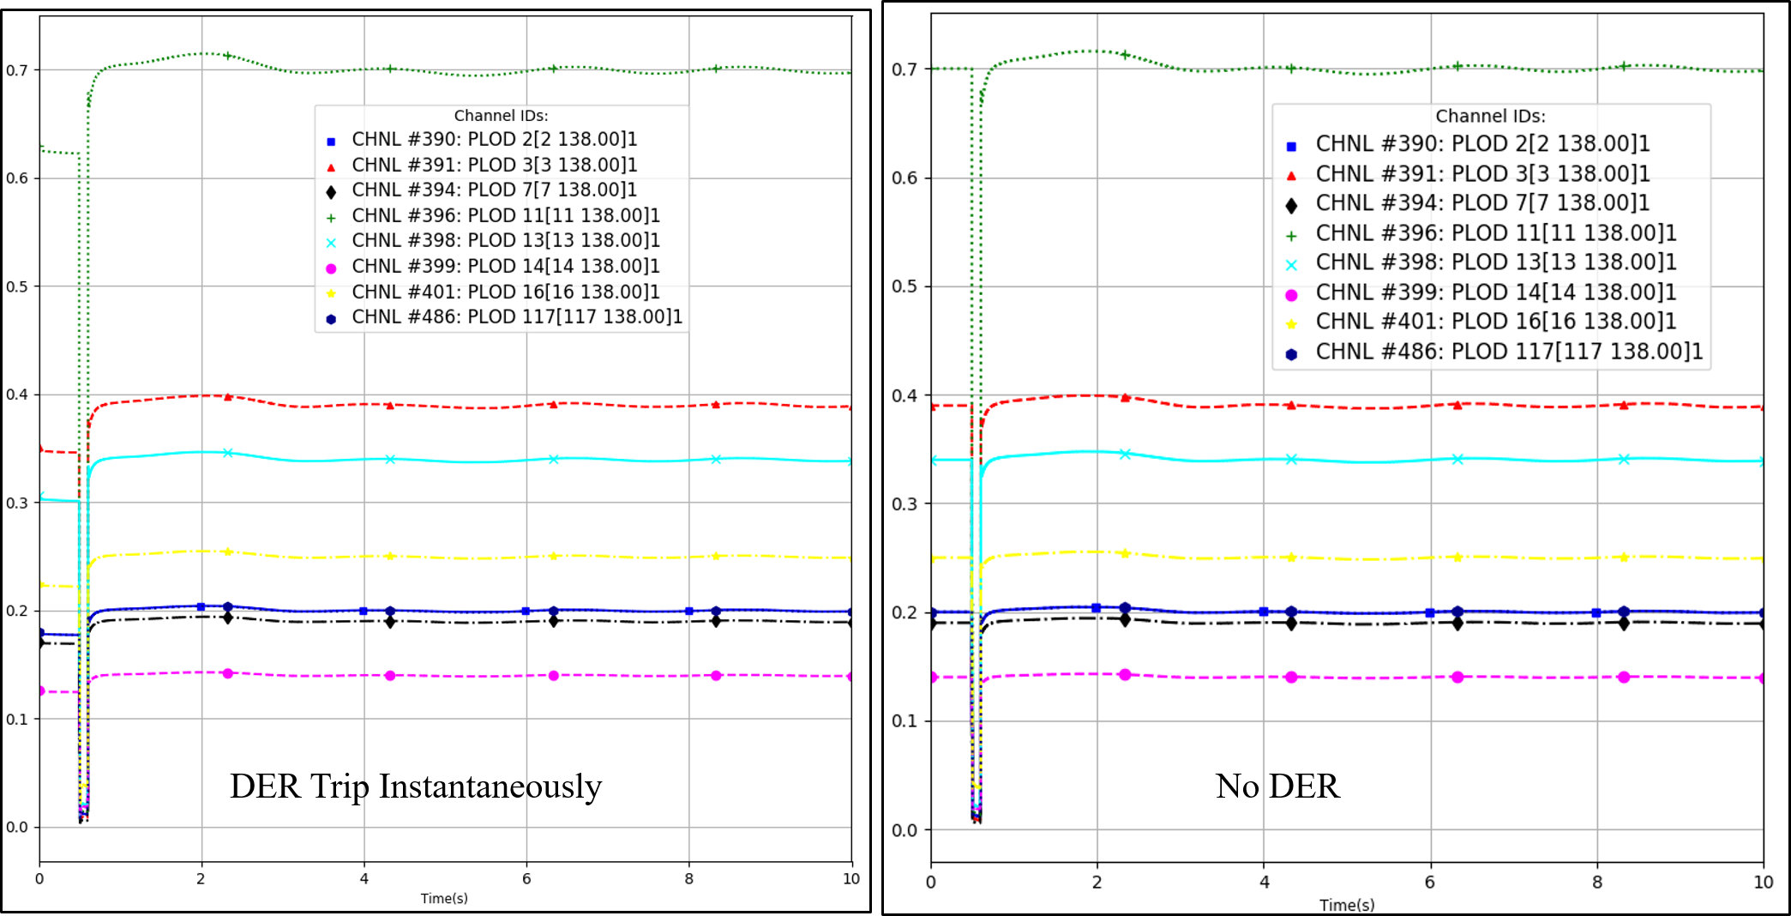 Figure 2: Active component of load as observed at the distribution system connected T-buses for the case with DER with Instantaneous Trip settings and with DER with Ride Through Settings.

Figure 2 shows the comparison of the net load in the distribution system connected buses with two different settings implemented in DER. With the ride through settings, the net load before and after the fault is same. However, with the instantaneous trip settings the net load after the fault is higher due to the DER tripping.

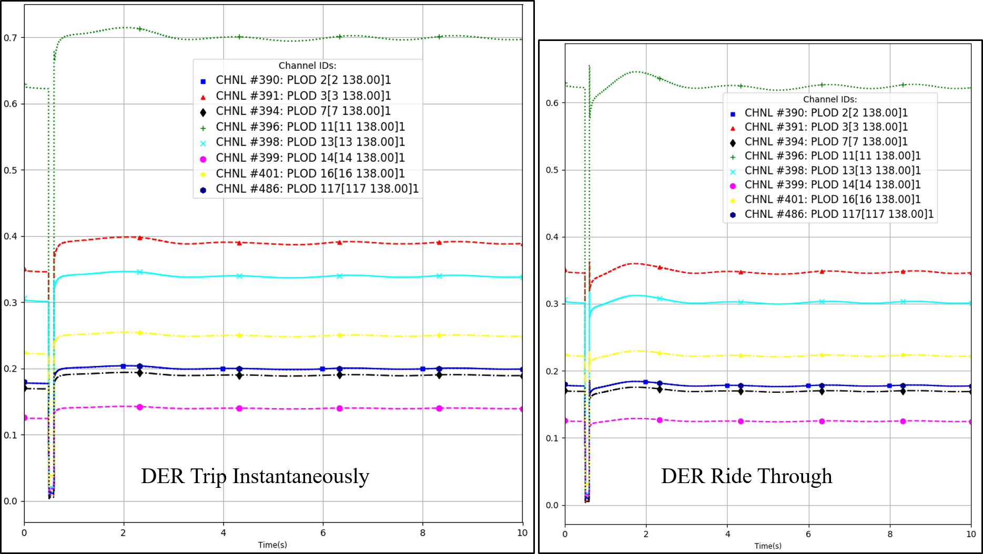 Figure 3: Active component of load as observed at the distribution system connected T-buses for the case with no DER and with DER with Instantaneous Trip Settings.

Figure 3 shows the comparison of the net load in the distribution system connected buses with instantaneous trip settings implemented in DER and with no DER in the distribution system. With the instantaneous trip settings, the net after the fault is same as the case with no DER. The difference between the post fault net load and pre-fault net load is the amount of DER that tripped due to the disturbance event.

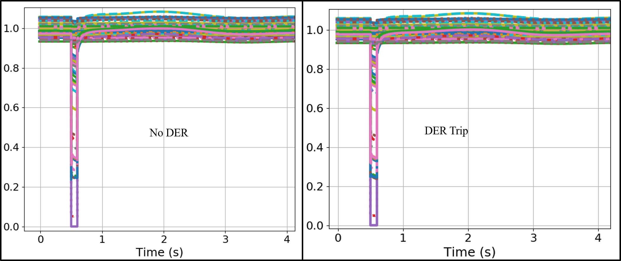 Figure 4: Transmission bus voltage comparison of the 118 bus system for the case with no DER with the case with DER with instantaneous trip settings.

Figure 4 compares the transmission bus voltage of the 118 bus system for the case with No DER and the case with instantaneous trip settings in DER. Much difference was not observed in this case as the overall DER penetration was low.

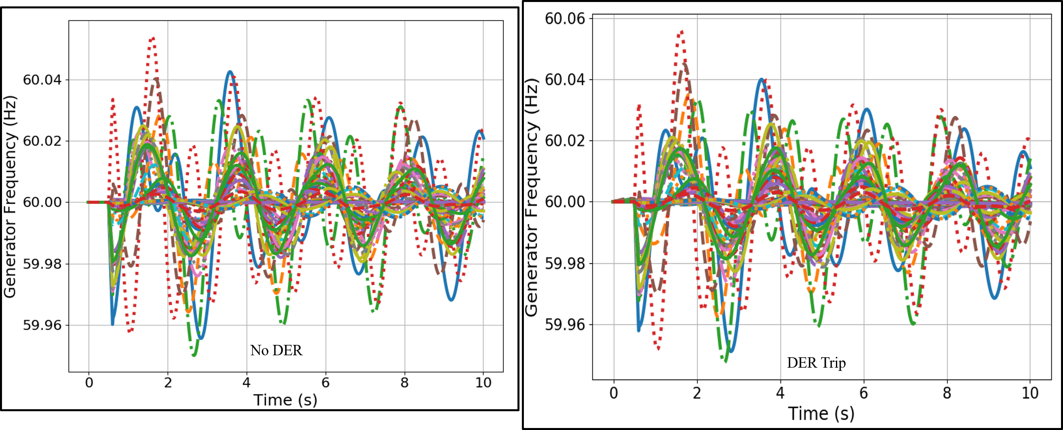 Figure 5: Generator Frequency comparison of the 118 bus system for the case with no DER with the case with DER with instantaneous trip settings.

Figure 5 compares the generator speed of the various generators in the 118 bus test system for the case with No DER and case with 10% DER with instantaneous trip settings. The speed response of the generators for these two cases are identical as the DER penetration level compared to the overall system is insignificant. However, some impact can be observed locally as in the case of generator 4 as shown in Figure 6. Figure 6 shows that the frequency response of the generator 4 is worst in the case in the DER in the system trip instantaneously.

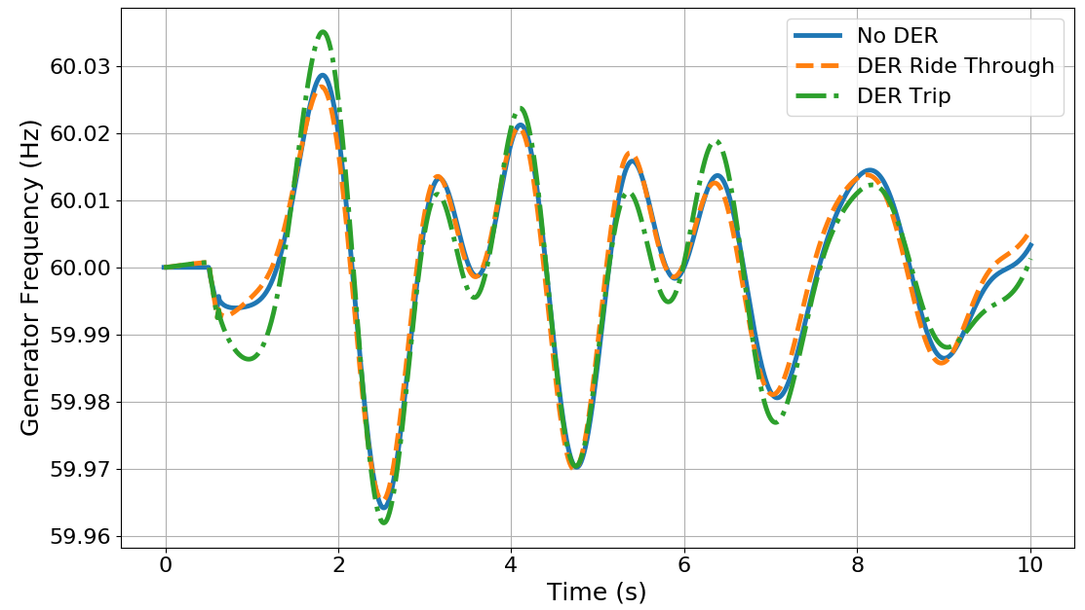 Figure 6: Generator Speed comparison of generator 4 for the three cases considered. a) No DER Case b) 10% DER with Ride Through Settings and c) 10% DER with instantaneous trip settings.

# Installation

TDcoSim can be installed from GitHub through command line as shown below.

git clone https://github.com/tdcosim/TDcoSim.git  
cd tdcosim/  
pip install -e .

***Note:*** [Git](https://git-scm.com/) needs to installed (incase it is not already available) before TDcoSim can be installed.

## Dependencies:

The packages listed below must be installed separately:

* [Python](https://www.python.org/) version = 2.7.5 for PSS®E, version = 33.3.0, version >= 3.5 for PSS®E, version = 35.0.0
* Power system simulator: [PSS®E, version = 33.3.0 or PSS®E, version = 35.0.0](https://new.siemens.com/global/en/products/energy/services/transmission-distribution-smart-grid/consulting-and-planning/pss-software/pss-e.html)
* Distribution system simulator: [OpenDSS, version >= 8.6.1.1](https://sourceforge.net/projects/electricdss/)
* DER simulator: [**Solar PV-DER simulation utility**](https://github.com/sibyjackgrove/SolarPV-DER-simulation-utility)
* Python packages: SciPy, Numpy, Matlplotlib, Pywin32, XlsxWriter, Psutil

***Note:*** Either demo (limited to 50 buses) or full version of PSS/E can be used. OpenDSS is an open source software and can be installed for free.

***Note:*** All Python packages can be installed with *pip* (e.g. *pip install scipy*)

***Note:*** Python 3.6/3.7 support will be added in the future.

# System Requirements

## Minimum requirements:

* OS: Windows 10
* Processor: Intel Core i7, 2.6 GHz, 2 cores
* Memory (RAM): 16.0 GB

## Recommended requirements:

* OS: Windows
* Processor: Intel Core i9, 4.4 GHz, 8 cores
* Memory (RAM): 64.0 GB

***Note:*** Capability to run on a cluster will be added in the future.

***Note:*** Solution time is influenced by the number of logical cores in CPU.

# References

1. [A combined transmission and distribution system co-simulation framework for assessing the impact of Volt/VAR control on transmission system](https://ieeexplore.ieee.org/document/8274633)
2. [Load Model Parameter Estimation by Transmission-Distribution Co-Simulation](https://ieeexplore.ieee.org/document/8442939)
3. [Dynamic Modeling of Solar PV Systems for Distribution System Stability Analysis](https://www.researchgate.net/publication/333985171_Dynamic_Modeling_of_Solar_PV_Systems_for_Distribution_System_Stability_Analysis)